

Software Design Documentation
BERNAMA Portal Content Management System (PCMS)

Volume 5

1 | Module: Event Calendar
2 | Module: Malaysia eBiz
3 | Module: Document Management

Version 1.1
Release Date: 9th July 2019

Project Title:
Membekal, Menghantar, Memasang, Merekabentuk, Membangun, Mengintegrasi, Menguji, Mentauliah, dan Menyelenggara Perkakasan dan Perisian Sistem Pengurusan Kandungan Portal (PCMS) Bernama.com dan Aplikasi Mudah Alih Telefon Pintar Bernama Mobile App bagi Platform iOS (BER/TDR/2/2016)

Document Control
Prepared By

Name | Title | Email
SHAZMIN FATIMAH ZUHAIRI | SYSTEM ANALYST  NOVAMI HOLDINGS SDN BHD | shazminzuhairi@novamiholdings.com
SITI NADIAH ABDUL HANAN | SYSTEM ANALYST  NOVAMI HOLDINGS SDN BHD | nadiahhanan@novamiholdings.com

Document Approval & Sign-Off
Name | Designation | Company | Signature
MOHAMAD RAZIF ROSELI | PROJECT MANAGER | NOVAMI HOLDINGS SDN BHD | DATE:
MASTURA HASSAN | PROJECT MANAGER | BERNAMA – PORTAL & E-DAGANG | DATE:
NOR SHAHUDA ATIKA NORDIN | PROJECT EXECUTIVE | BERNAMA – PORTAL & E-DAGANG | DATE:
MARDIANA AHMAD | SENIOR WEBMASTER | BERNAMA – PORTAL & E-DAGANG | DATE:
ABU BAKAR MOHAMED | SENIOR WEBMASTER | BERNAMA – PORTAL & E-DAGANG | DATE:

Revision History
Date | Version | Description | Author
19/09/2018 | Draft 1.0 | First release | SHAZMIN FATIMAH ZUHAIRI  SITI NADIAH ABDUL HANAN
24/01/2019 | Version 1.0 | Volume 5 | SITI NADIAH ABDUL HANAN
09/07/2019 | Version 1.1 | Update Module Event Calendar | SITI NADIAH ABDUL HANAN

Table of Content
Document Control 2
Document Approval & Sign-Off 3
Revision History 4
1 Module: Event Calendar 6
1.1 Use Case 6
1.2 Use Case Description 6
1.3 Add Event 8
1.4 View Event 11
1.5 View Calendar 13
1.6 Edit Event 15
1.7 Delete Event 18
2 Module: Malaysia eBiz 21
2.1 Use Case 21
2.2 Use Case Description 22
2.3 Add Weekly Roundup 23
2.4 View Weekly Roundup 26
2.5 Edit Weekly Roundup 28
2.6 Delete Weekly Roundup 31
2.7 Add Edition 33
2.8 View Edition 36
2.9 Edit Edition 38
2.10 Delete Edition 41
2.11 Add Market Outlook 44
2.12 View Market Outlook 48
2.13 Edit Market Outlook 51
2.14 Delete Market Outlook 55
2.15 Add Archive 58
2.16 View Archive 60
2.17 Edit Archive 63
2.18 Delete Archive 66
3 Module: Document Management 69
3.1 Use Case 69
3.2 Use Case Description 69
3.3 Add Document 71
3.4 View Document 74
3.5 Edit Document 76
3.6 Delete Document 79

Module: Event Calendar

Use Case
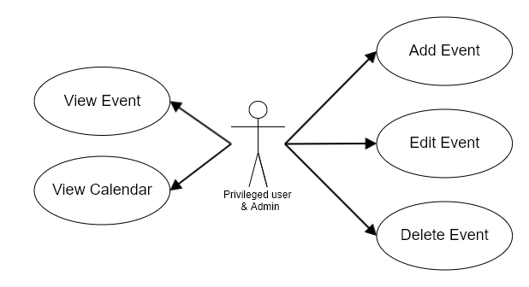
Use Case: Event calendar

Use Case Description
Use Case | Description
Add Event | - Required privilege for Actor: Menu – Event Calendar, Add Event.  - Privileged user can add new event by entering event’s information and assign it to attendee(s).  - Each event that has been assigned to user will displayed in their dashboard.  - An email notification will be sent to selected users upon event creation, update & delete.
View Event | - Required privilege for Actor: Menu – Event Calendar, Manage Event.  - Privileged user can view all the created event.  - System will display the information of event.
View Calendar | - Required privilege for Actor: Menu – Event Calendar, Manage Event.  - Privileged user can view all events in calendar form.  - Only Event Title and Start Time of event are shown in calendar.
Edit Event | - Required privilege for Actor: Menu – Event Calendar, Manage Event.  - Privileged user can edit all the event.  - An email notification will be sent to selected users upon event creation, update & delete.
Delete Event | - Required privilege for Actor: Menu – Event Calendar, Manage Event.  - Privileged user able to delete either single or multiple selection for delete function.  - An email notification will be sent to selected users upon event creation, update & delete.

Add Event

Flowchart
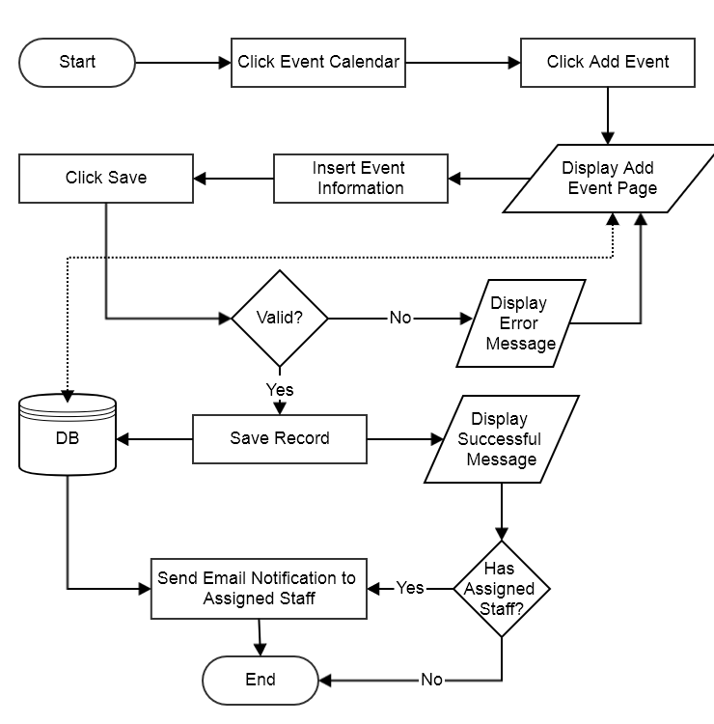
Flowchart: Add Event

Sequence Diagram
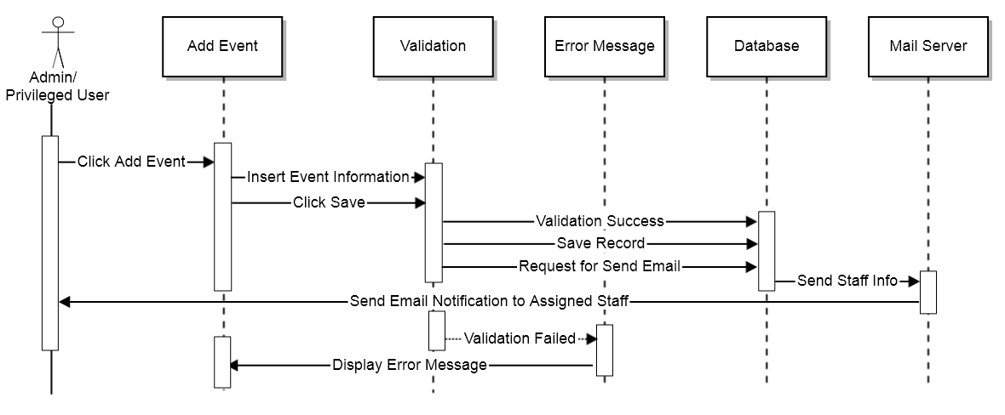
Sequence Diagram: Add Event

Form Parameter
Request Parameter | Description | Type | Default | Required
Event title | Event title | Text | N/A | Yes
Event Description | Event description | Text | N/A | No
Start Date | Start date | Date | N/A | Yes
End Date | End date | Date | N/A | Yes
Note/Remarks | Remarks | Text | N/A | No
Site Category | Site category | Dropdown | N/A | No
List of site category | List of site category | Dropdown | N/A | No
Language | Language | Dropdown | N/A | No
News category | News category | Dropdown | N/A | No
Upload file (invitation) | Upload attachment | File | N/A | No
Select staff | Select attendees | Dropdown | N/A | No

Error Message
No | Message | Type | Description
1 | The Event Title is required | Alert | Field cannot be null
2 | The Start Date field is required | Alert | Field cannot be null
3 | The End Date field is required | Alert | Field cannot be null

Screen Layout
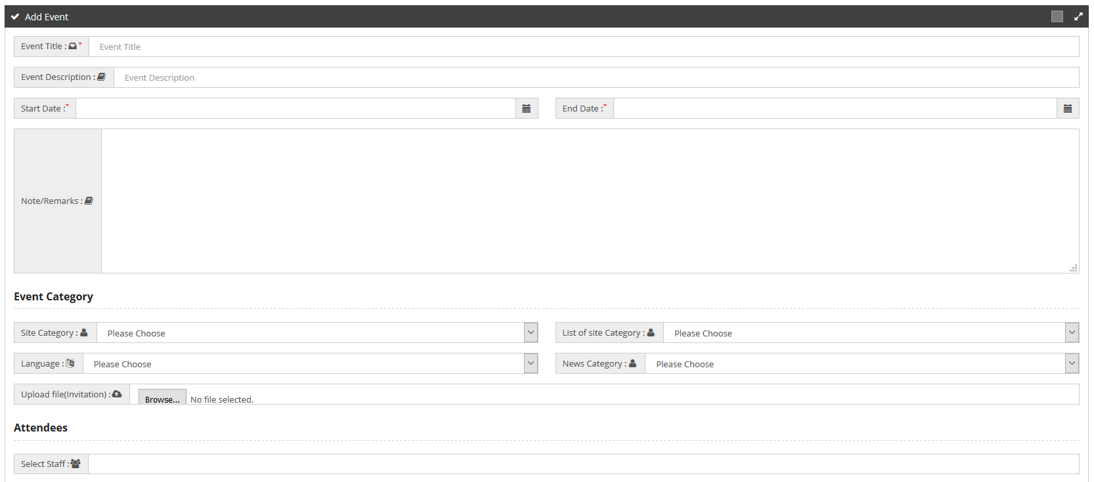
Screen Layout: Add Event

View Event

Flowchart
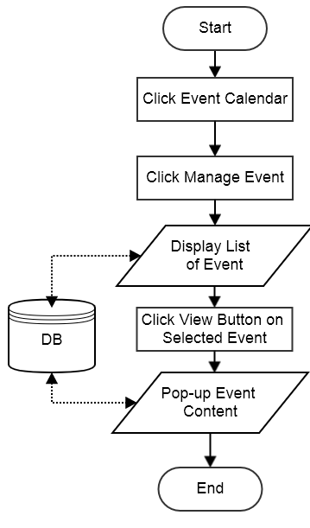
Flowchart: View Event

Sequence Diagram
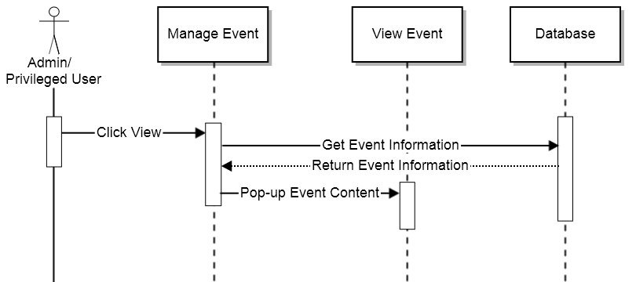
Sequence Diagram: View Event

Error Message
N/A

Form Parameter
N/A

Screen Layout
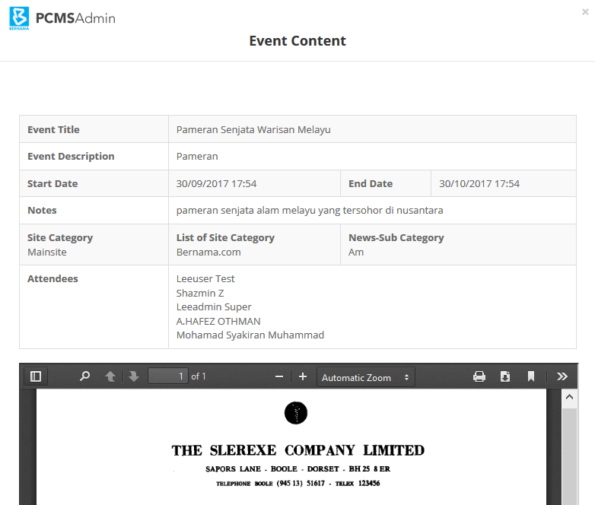
Screen Layout: View Event

View Calendar

Flowchart
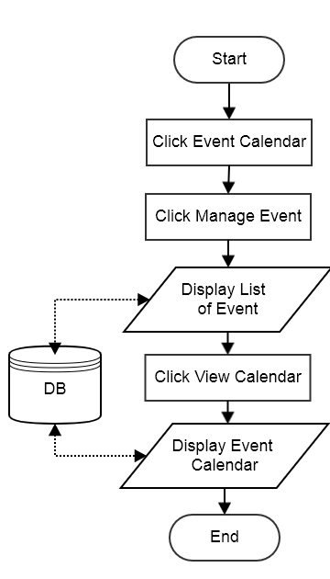
Flowchart: View Calendar

Sequence Diagram
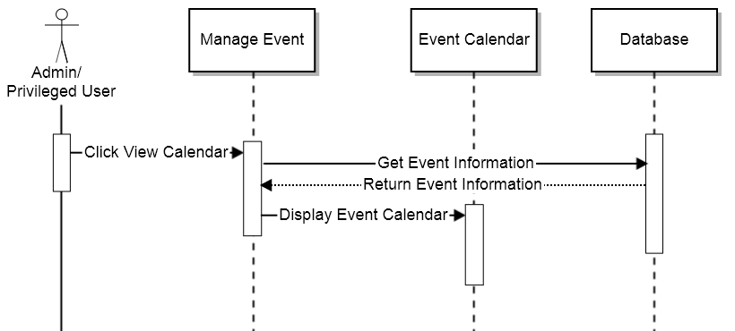
Sequence Diagram: View Calendar

Form Parameter
N/A

Error Message
N/A

Screen Layout
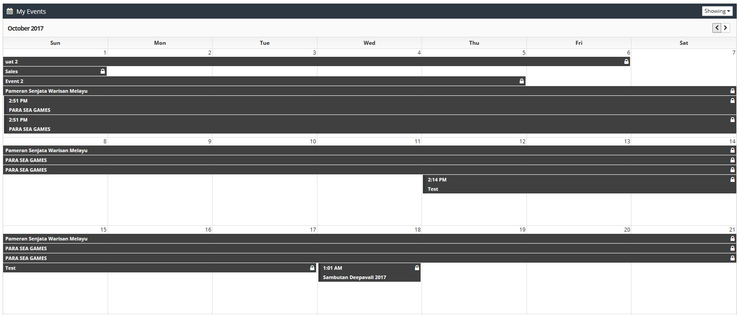
Screen Layout: View Event

Edit Event

Flowchart
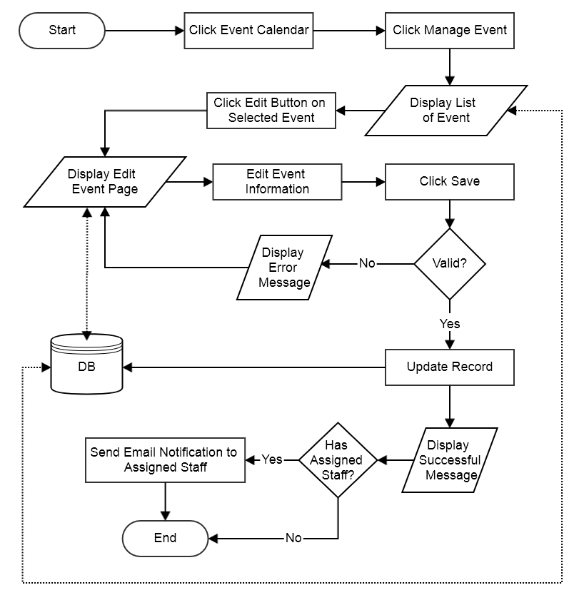
Flowchart: Edit Event

Sequence Diagram
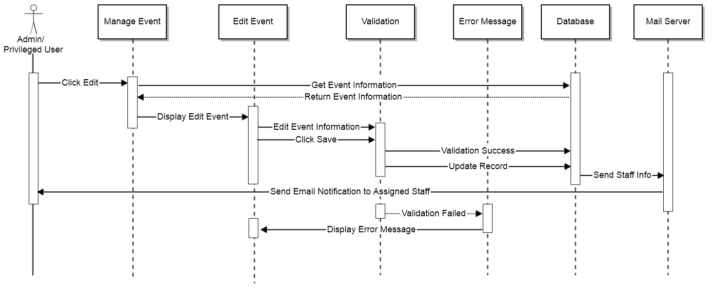
Sequence Diagram: Edit Event

Form Parameter
Request Parameter | Description | Type | Default | Required
Event title | Event title | Text | Previously saved data | Yes
Event Description | Event description | Text | Previously saved data | No
Start Date | Start date | Date | Previously saved data | Yes
End date | End date | Date | Previously saved data | Yes
Note/Remarks | Remarks | Text | Previously saved data | No
Site Category | Site category | Dropdown | Previously saved data | No
List of site category | List of site category | Dropdown | Previously saved data | No
Language | Language | Dropdown | Previously saved data | No
News category | News category | Dropdown | Previously saved data | No
Upload file (invitation) | Upload attachment | File | Previously saved data | No
Select staff | Select attendees | Dropdown | Previously saved data | No

Error Message
No | Message | Type | Description
1 | The Event Title is required | Alert | Field cannot be null
2 | The Start Date field is required | Alert | Field cannot be null
3 | The End Date field is required | Alert | Field cannot be null

Screen Layout
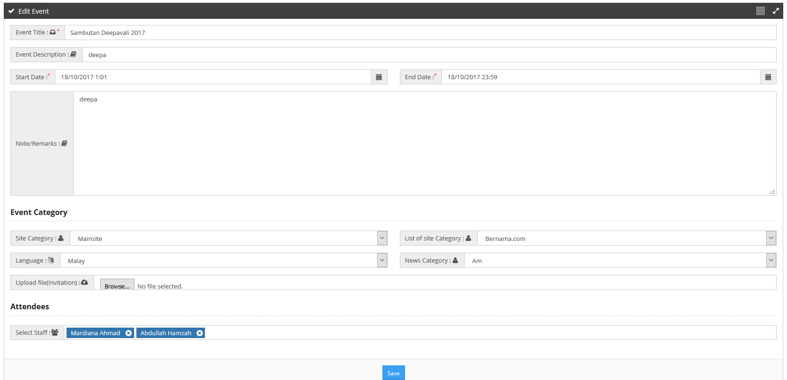
Screen Layout: Edit Event

Delete Event

Flowchart
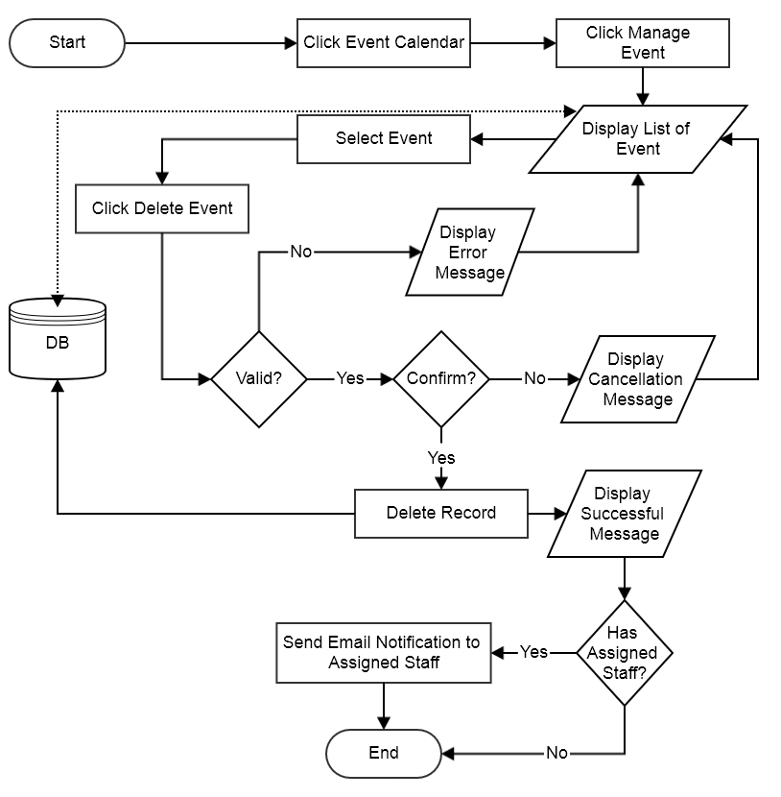
Flowchart: Delete Event

Sequence Diagram
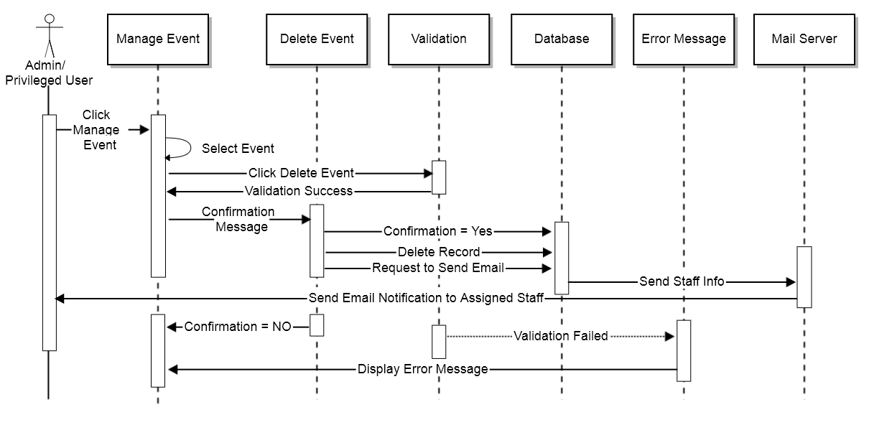
Sequence Diagram: Delete Event

Form Parameter
N/A

Error Message
No | Message | Type | Description
1 | Please select at least one event | Alert | Field cannot be null

Screen Layout
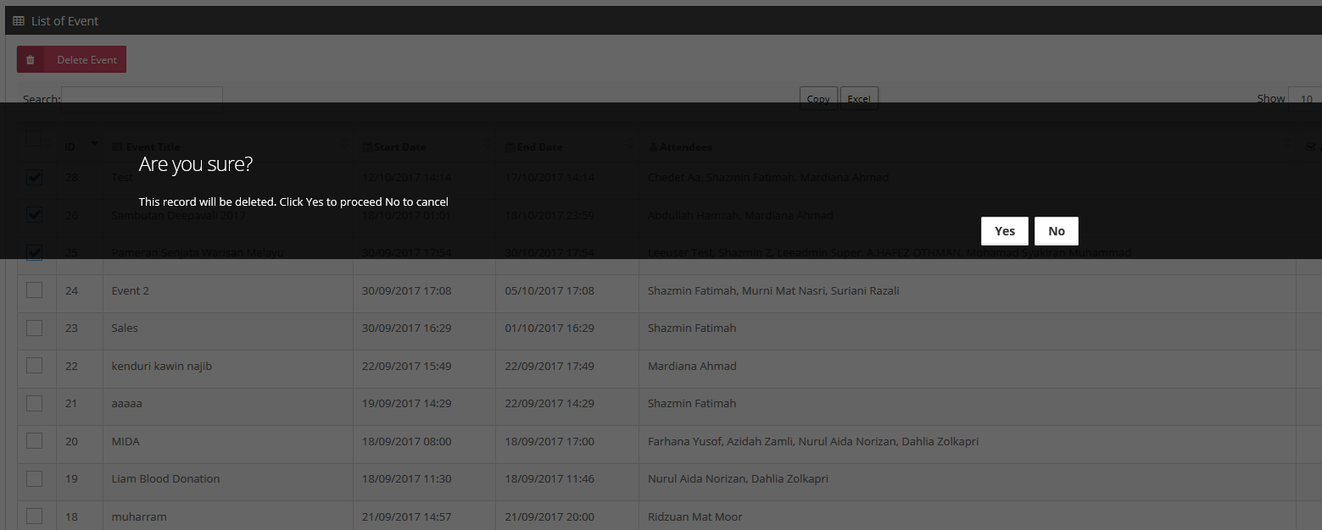
Screen Layout: Delete Event

Module: Malaysia eBiz

Use Case
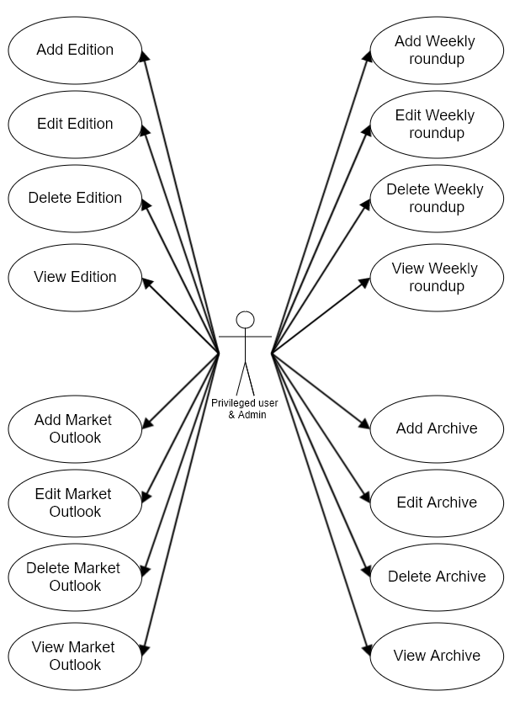
Malaysia eBiz

Use Case Description
Malaysia eBiz module provides template for multiple format of contents upload. This module consists of three (3) content categories known as:

• Weekly Roundup which is published every Friday in .pdf & flash file format.
• Market Outlook which is published every Saturday that consists of nine (9) categories;
- Bursa Malaysia
- Forex
- Money Market
- FBM KLCI Futures
- Crude Palm Oil (CPO) Futures
- Rubber Futures
- KLIBOR Futures
- Kuala Lumpur Tin Market (KLTM)
- Gold Futures
• Archive which is published in .pdf & flash file format.

Multiple selection for delete function will be included as well as filter and sort functions within the system’s search feature. Other than that, this module is able to:

• Create, read, update and delete Weekly Roundup
• Create, read, update and delete Edition
• Create, read, update and delete Market Outlook
• Create, read, update and delete Archive

Under module Malaysia eBiz, privileged user should be able to access the following sub module:
- Weekly Roundup
This sub module display list of weekly roundups that can be manage by privilege user. Privileged user has the access to add, edit, view and delete weekly roundup files. Each weekly roundup is named accordingly based on its edition number. Every edition should have pdf file and several other types of files (swf, html, images).

- Market Outlook
This sub module display list of editions containing market outlooks. A complete edition must contain market outlook news from the 9 categories. Hence, user must first create an edition before proceeding on adding market outlook news. In this sub module, privileged user has the access to manage editions (add, edit, view and delete) and manage market outlook news (add, edit, view and delete).

- Archive
This sub module display list of archives of both weekly roundup and market outlook Privileged user has the access to add, edit, view and delete archive files. Each weekly roundup is named accordingly based on its edition number. Every edition should have pdf file and several other types of files (swf, html, images).

Add Weekly Roundup

Flowchart
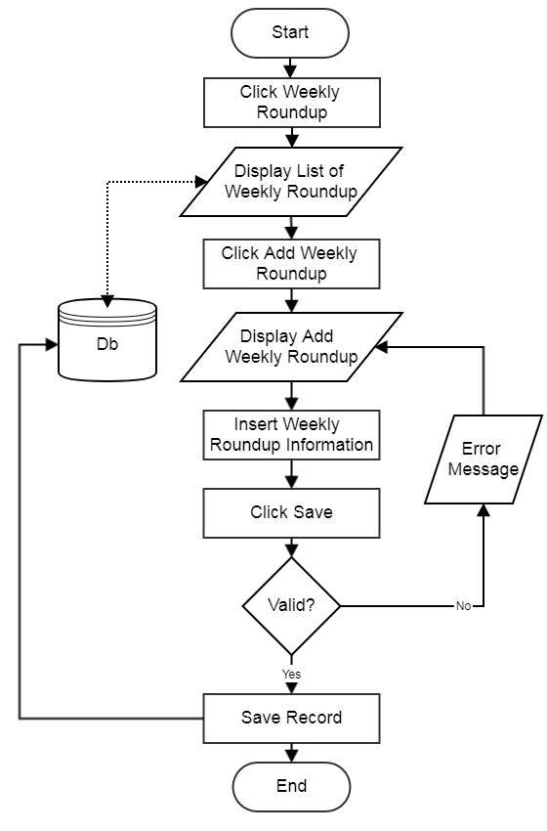
Flowchart: Add Weekly Roundup

Sequence Diagram
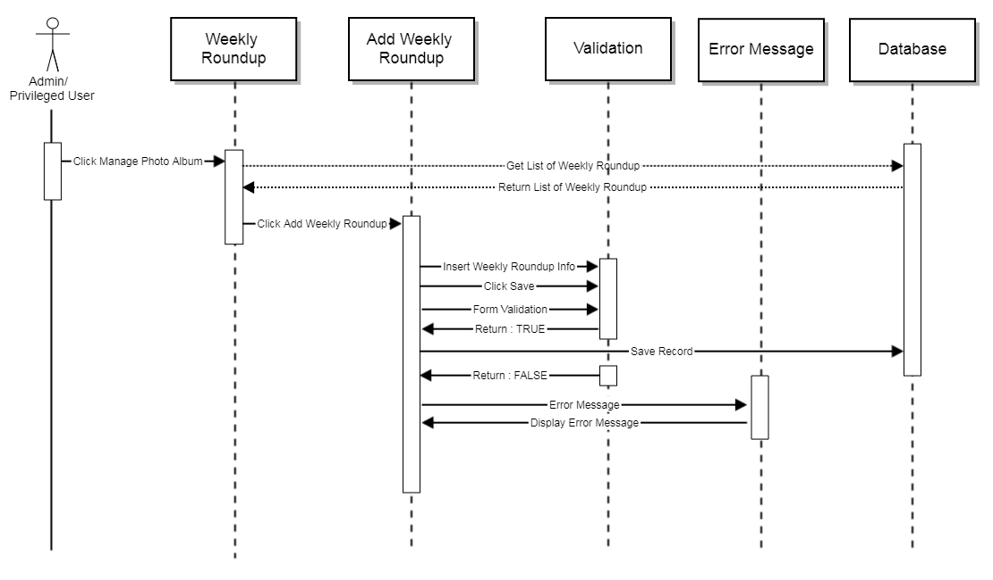
Sequence Diagram: Add Weekly Roundup

Form Parameter
Request Parameter | Description | Type | Default | Required
Edition | Edition title | Text | N/A | Yes
Upload PDF | Upload file | File | N/A | Yes
Upload SWF | Upload file | File | N/A | No
Status | Status | Dropdown | N/A | Yes
Notes | Note | Text | N/A | No

Error Message
No | Message | Type | Description
1 | The title name field is required | Alert | Field cannot be null
2 | The pdf field is required | Alert | Field cannot be null
3 | The title status field is required | Alert | Field cannot be null

Screen Layout
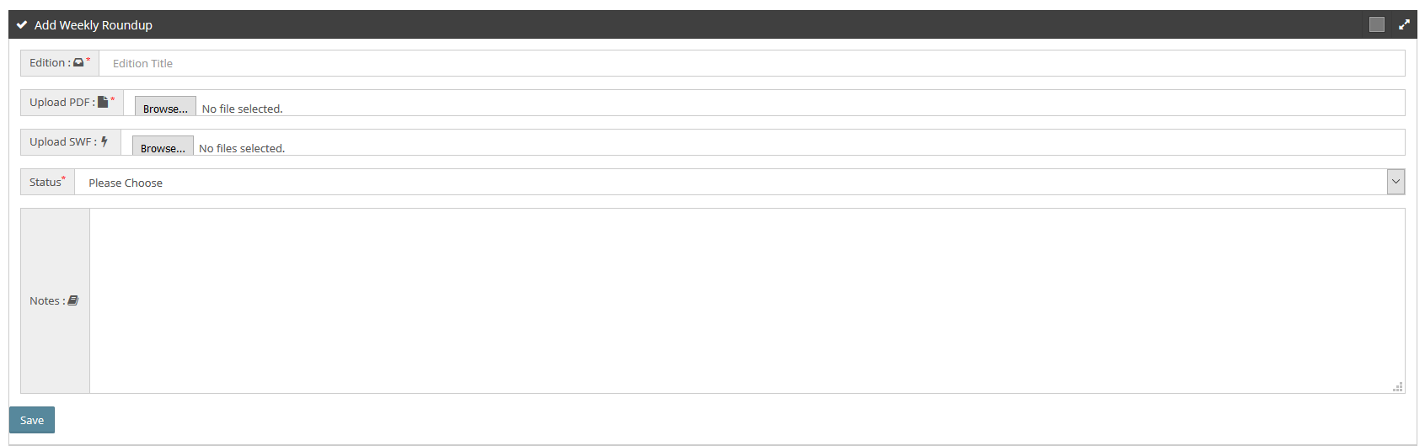
Screen Layout: Add Weekly Roundup

View Weekly Roundup

Flowchart
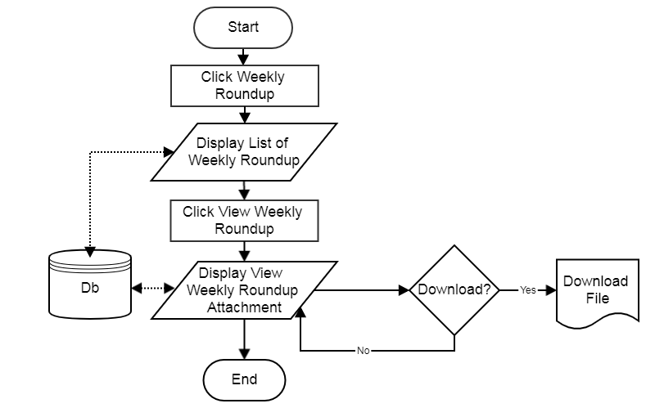
Flowchart: View Weekly roundup

Sequence Diagram
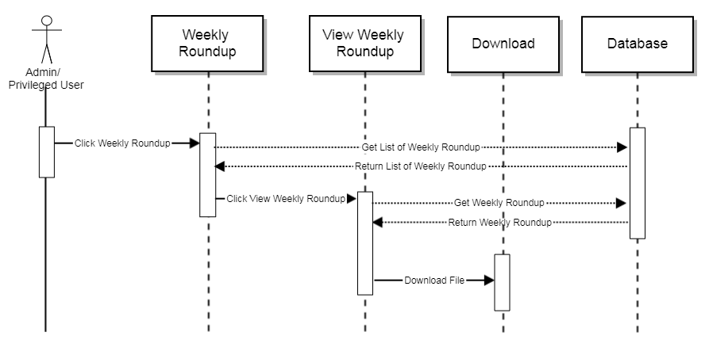Sequence Diagram: View Weekly Roundup

Form Parameter
N/A

Error Message
N/A

Screen Layout
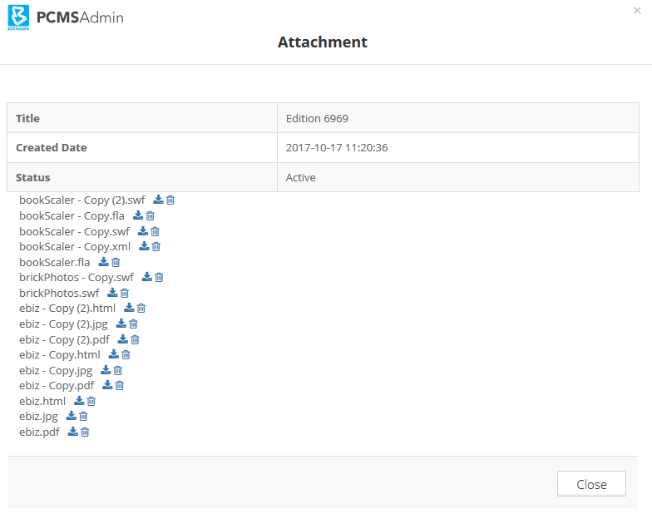
Screen Layout: View Weekly Roundup

Edit Weekly Roundup

Flowchart
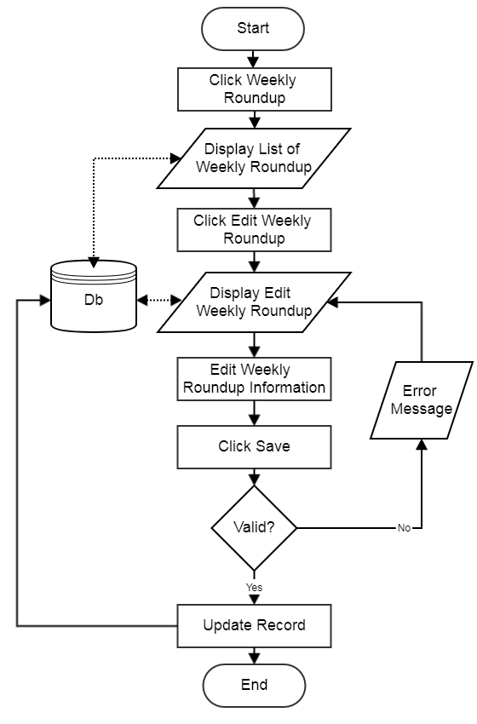
Flowchart: Edit Weekly Roundup

Sequence Diagram
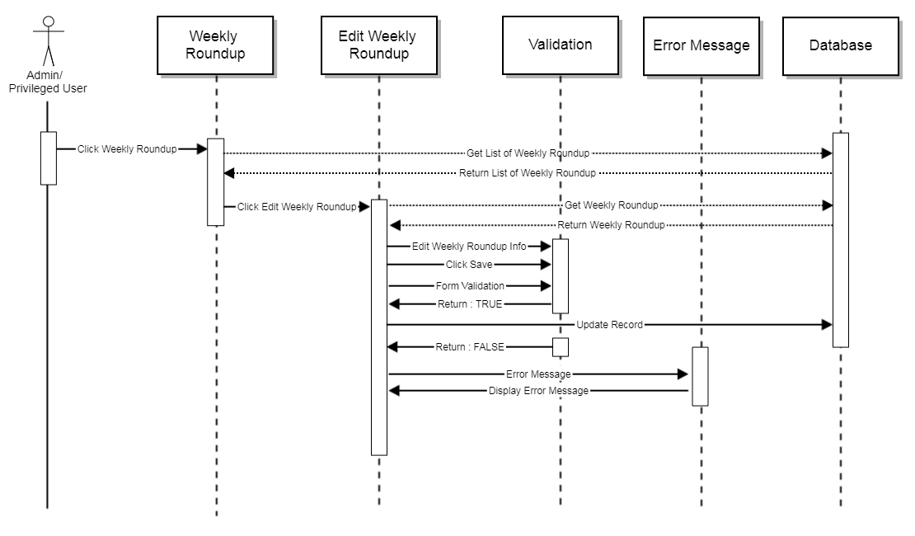
Sequence Diagram: Edit Weekly Roundup

Form Parameter
Request Parameter | Description | Type | Default | Required
Edition | Edition title | Text | Previously saved data | Yes
Upload PDF | Upload file | File | Previously saved data | Yes
Upload SWF | Upload file | File | Previously saved data | No
Status | Status | Dropdown | Previously saved data | Yes
Notes | Note | Text | Previously saved data | No

Error Message
No | Message | Type | Description
1 | The title name field is required | Alert | Field cannot be null
2 | The pdf field is required | Alert | Field cannot be null
3 | The title status field is required | Alert | Field cannot be null

Screen Layout
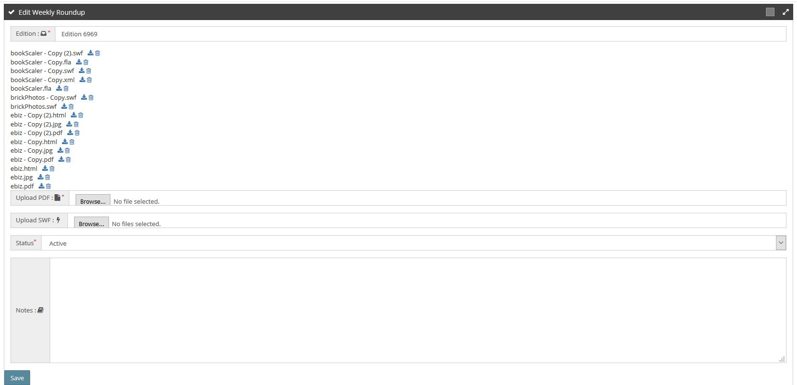
Screen Layout: Edit Weekly Roundup

Delete Weekly Roundup

Flowchart
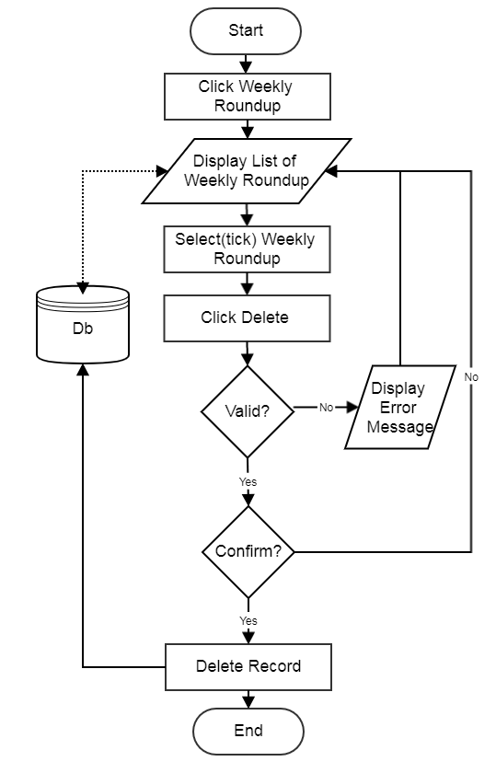
Flowchart: Delete Weekly Roundup

Sequence Diagram
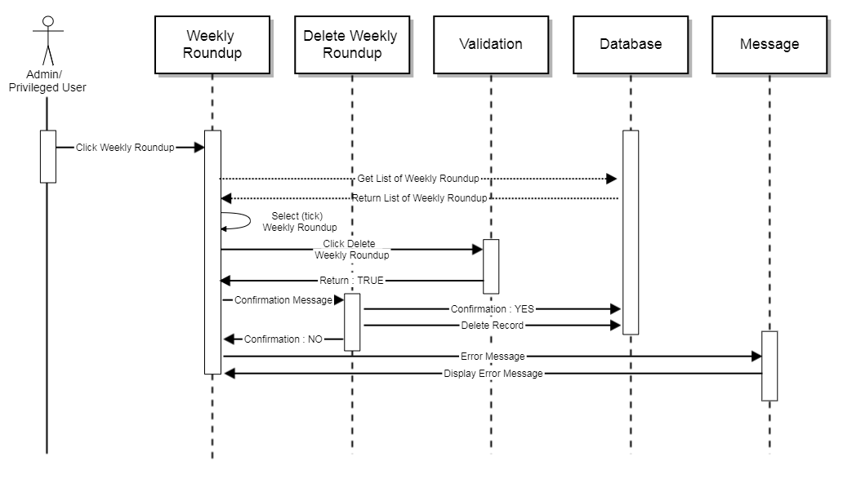
Sequence Diagram: Delete Weekly Roundup

Form Parameter
N/A

Error Message
No | Message | Type | Description
1 | Please Select at least one | Alert | Field cannot be null

Screen Layout
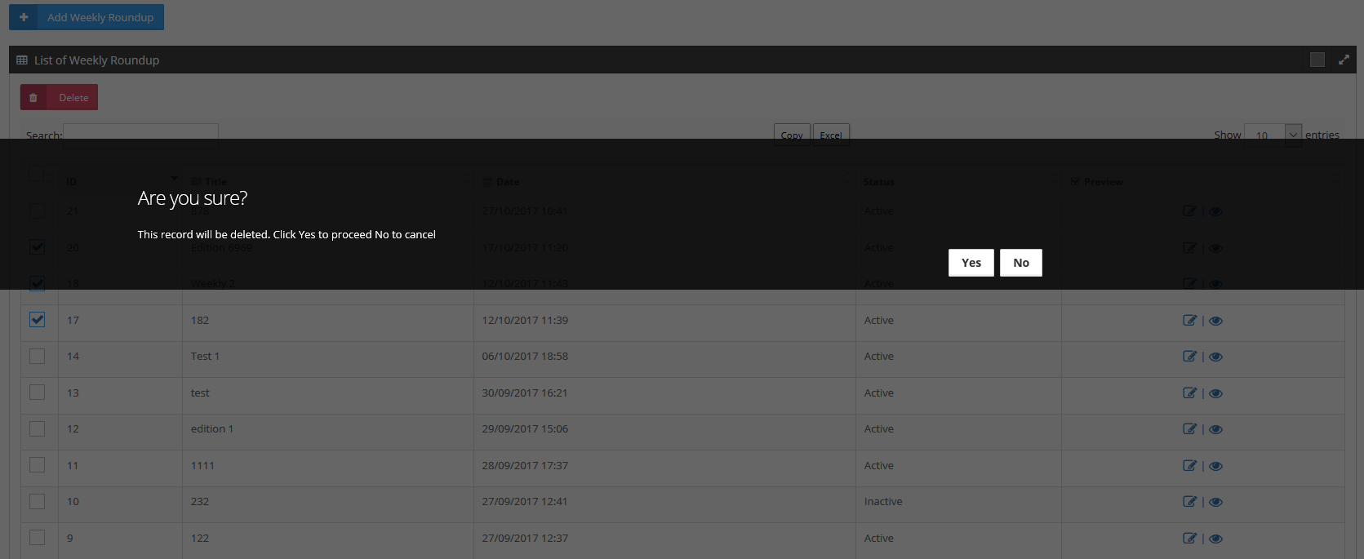
Screen Layout: Delete Weekly Roundup

Add Edition

Flowchart
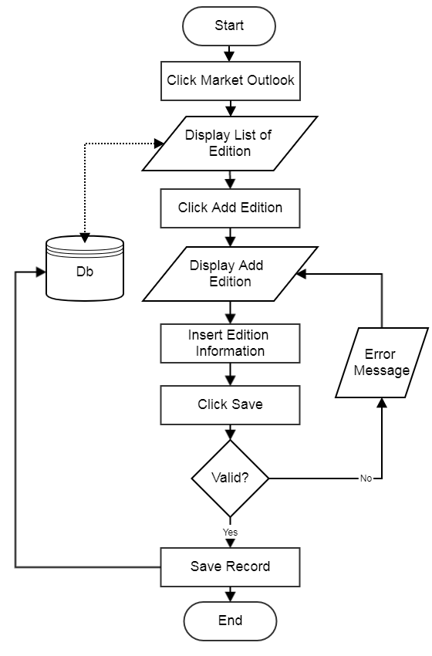
Flowchart: Add Edition

Sequence Diagram
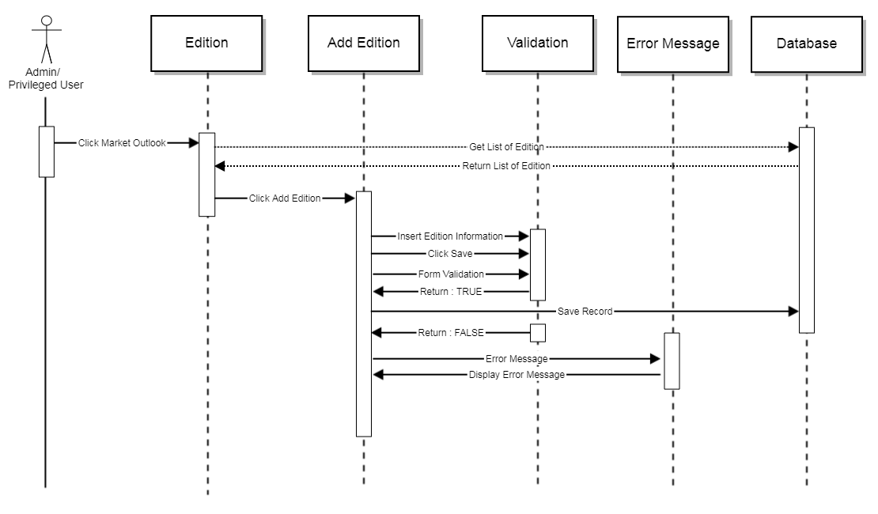
Sequence Diagram: Add Edition

Form Parameter
Request Parameter | Description | Type | Default | Required
Edition | Edition title | Text | N/A | Yes
Description | Description | Text | N/A | Yes

Error Message
No | Message | Type | Description
1 | The edition name field is required | Alert | Field cannot be null
2 | The edition description field is required | Alert | Field cannot be null
3 | The edition name has already been taken | Alert | Edition name is unique

Screen Layout
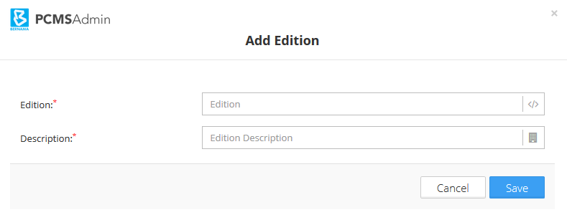
Screen Layout: Add Edition

View Edition

Flowchart
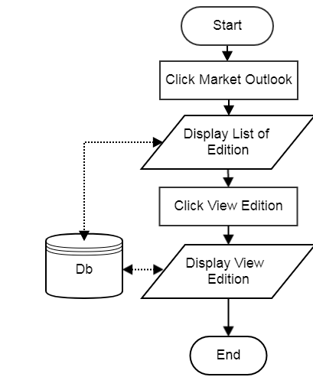
Flowchart: View Edition

Sequence Diagram
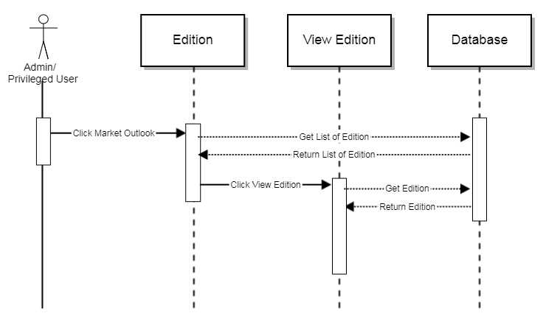
Sequence Diagram: View Edition

Form Parameter
N/A

Error Message
N/A

Screen Layout
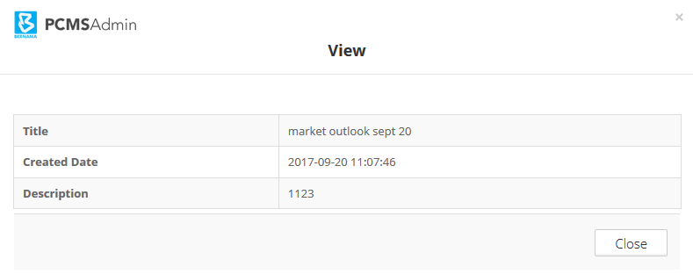
Screen Layout: View Edition

Edit Edition

Flowchart
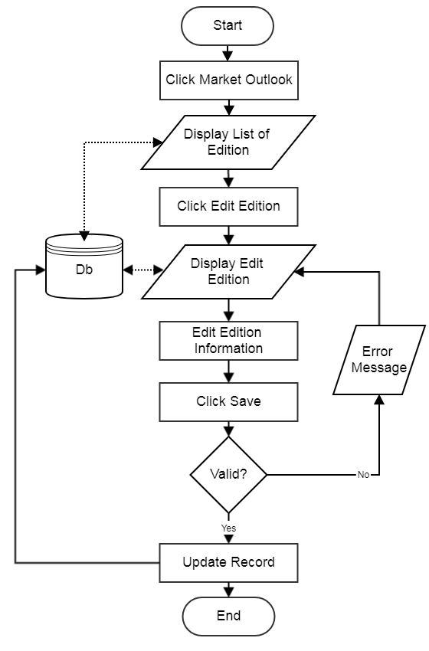
Flowchart: Edit Edition

Sequence Diagram
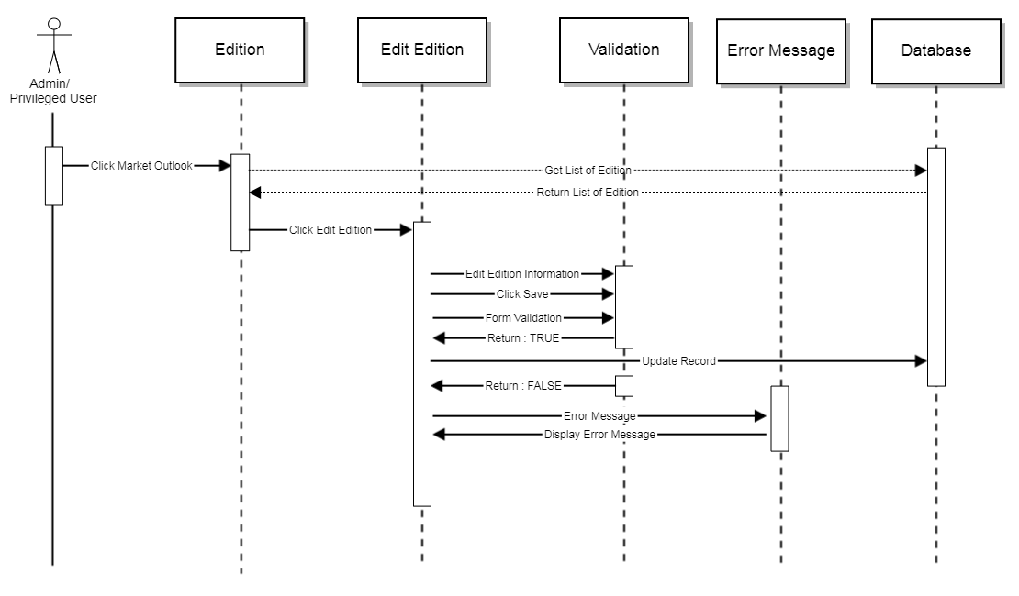
Sequence Diagram: Edit Edition

Form Parameter
Request Parameter | Description | Type | Default | Required
Edition | Edition title | Text | Previously saved data | Yes
Description | Description | Text | Previously saved data | Yes

Error Message
No | Message | Type | Description
1 | The edition name field is required | Alert | Field cannot be null
2 | The edition description field is required | Alert | Field cannot be null
3 | The edition name has already been taken | Alert | Edition name is unique

Screen Layout
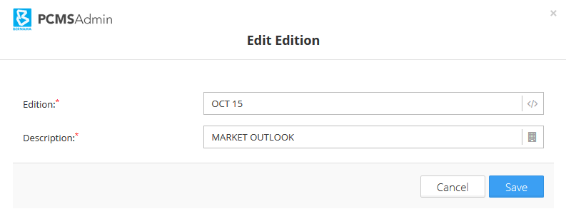
Screen Layout: Edit Edition

Delete Edition

Flowchart
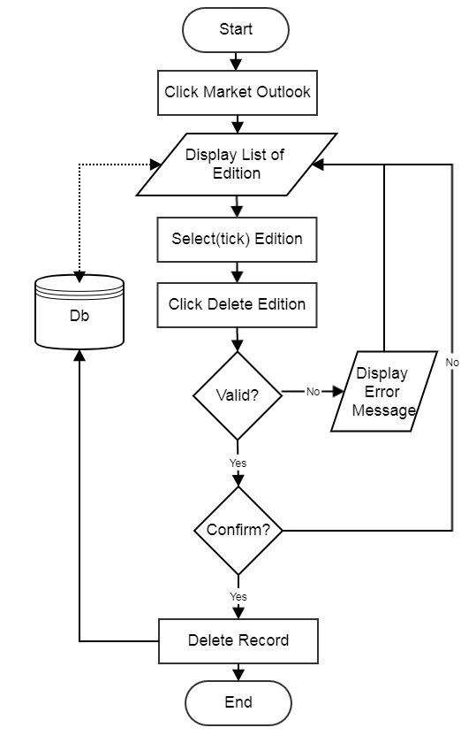
Flowchart: Delete Edition

Sequence Diagram
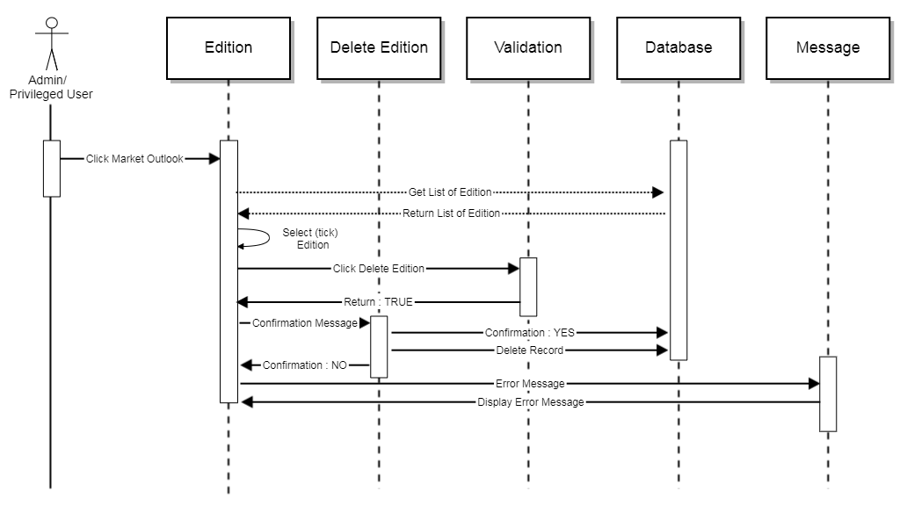
Sequence Diagram: Delete Edition

Form Parameter
N/A

Error Message
No | Message | Type | Description
1 | Please Select at least one | Alert | Field cannot be null

Screen Layout
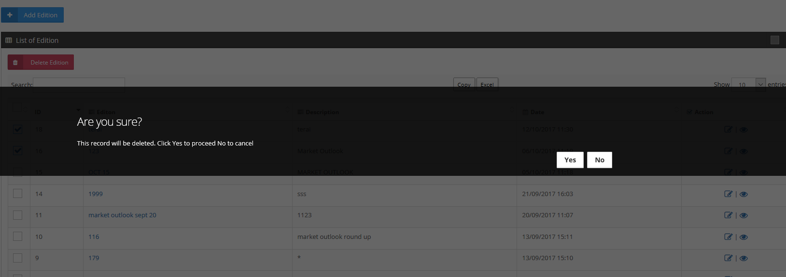
Screen Layout: Delete Edition

Add Market Outlook

Flowchart
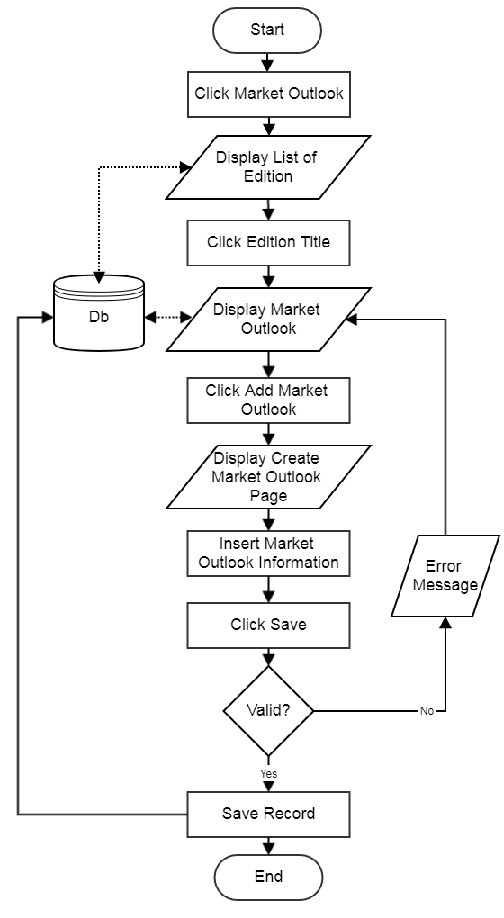
Flowchart: Add Market Outlook

Sequence Diagram
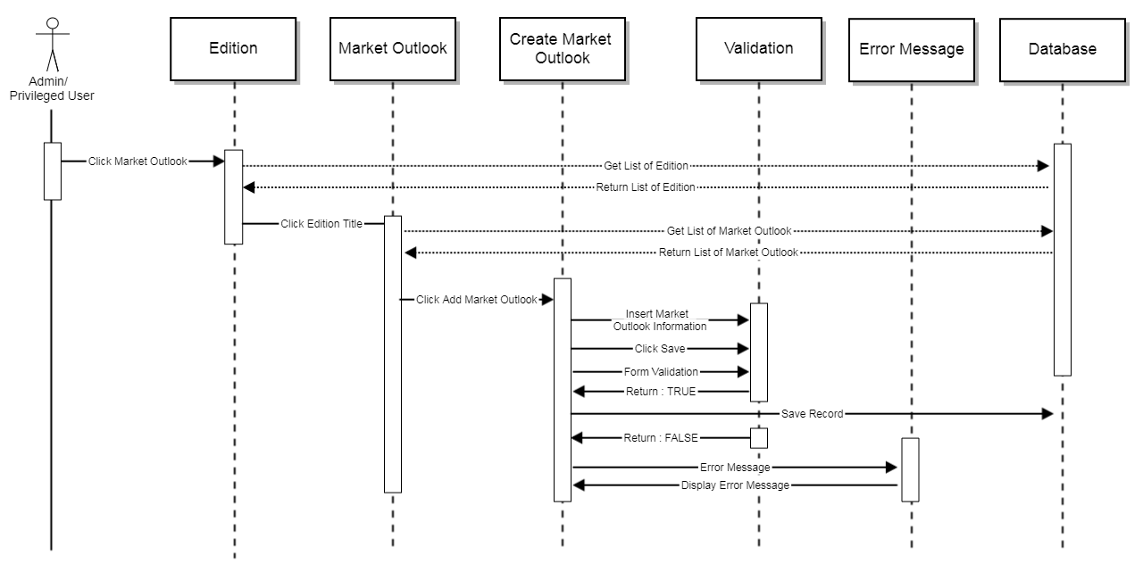
Sequence Diagram: Add Market Outlook

Form Parameter
Request Parameter | Description | Type | Default | Required
Headline | Headline title | Text | N/A | Yes
Description | Description | Text | N/A | No
Category | Market Outlook category | Dropdown | N/A | Yes
Date | Date created | Date | N/A | No
Status | Status | Dropdown | N/A | Yes
News content | Market Outlook content | Text | N/A | Yes

Error Message
No | Message | Type | Description
1 | The title name field is required | Alert | Field cannot be null
2 | The title category description field is required | Alert | Field cannot be null
3 | The title status field is required | Alert | Field cannot be null
4 | The news content field is required | Alert | Field cannot be null

Screen Layout
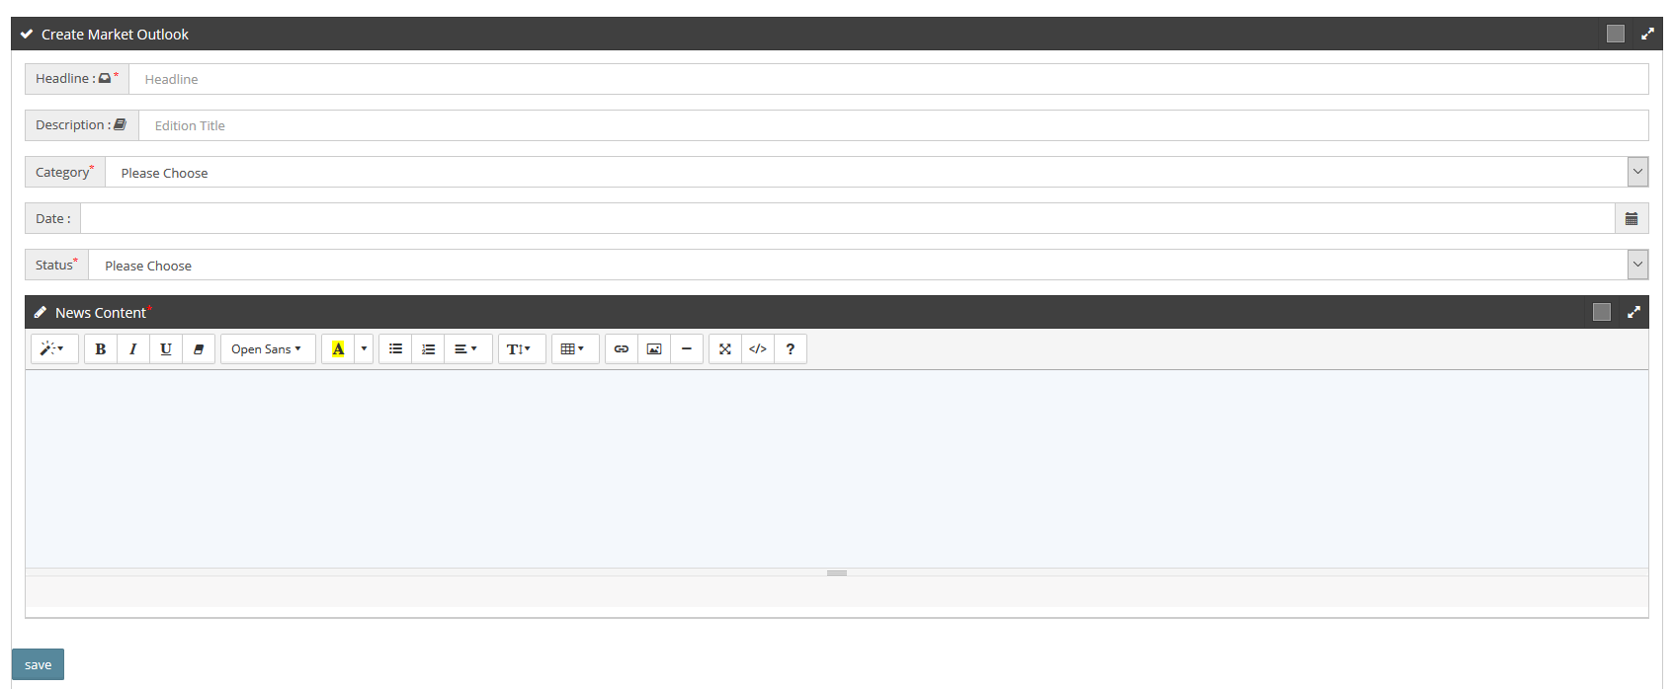
Screen Layout: Create Market Outlook

View Market Outlook

Flowchart
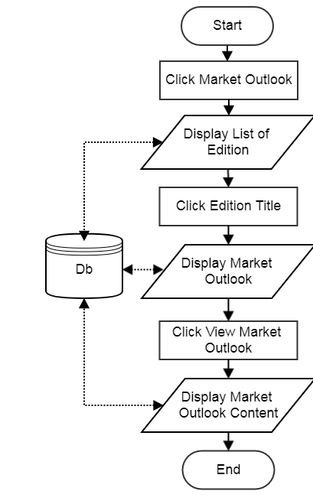
Flowchart: View Market Outlook

Sequence Diagram
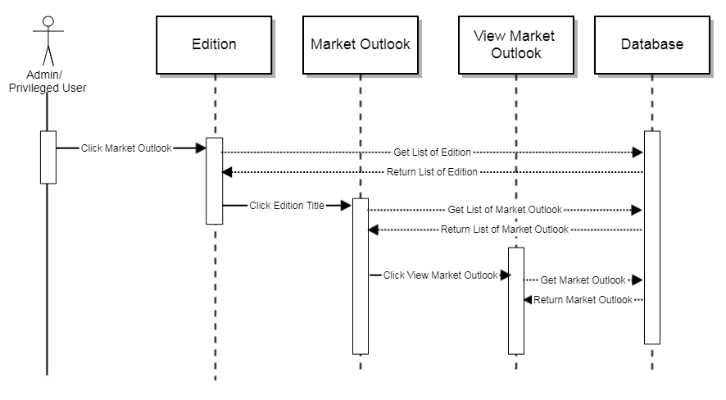
Sequence Diagram: View Market Outlook

Form Parameter
N/A

Error Message
N/A

Screen Layout
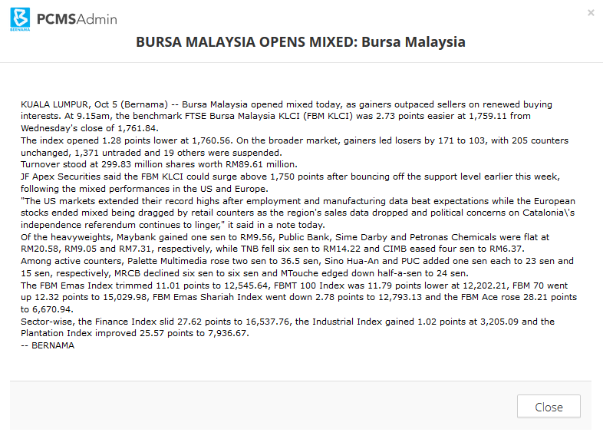
Screen Layout: View Market Outlook

Edit Market Outlook

Flowchart
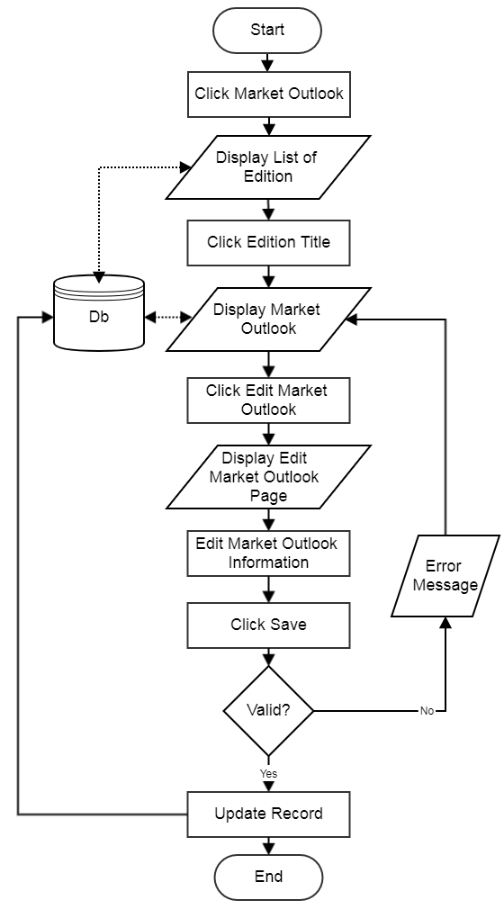
Flowchart: Edit Market Outlook

Sequence Diagram
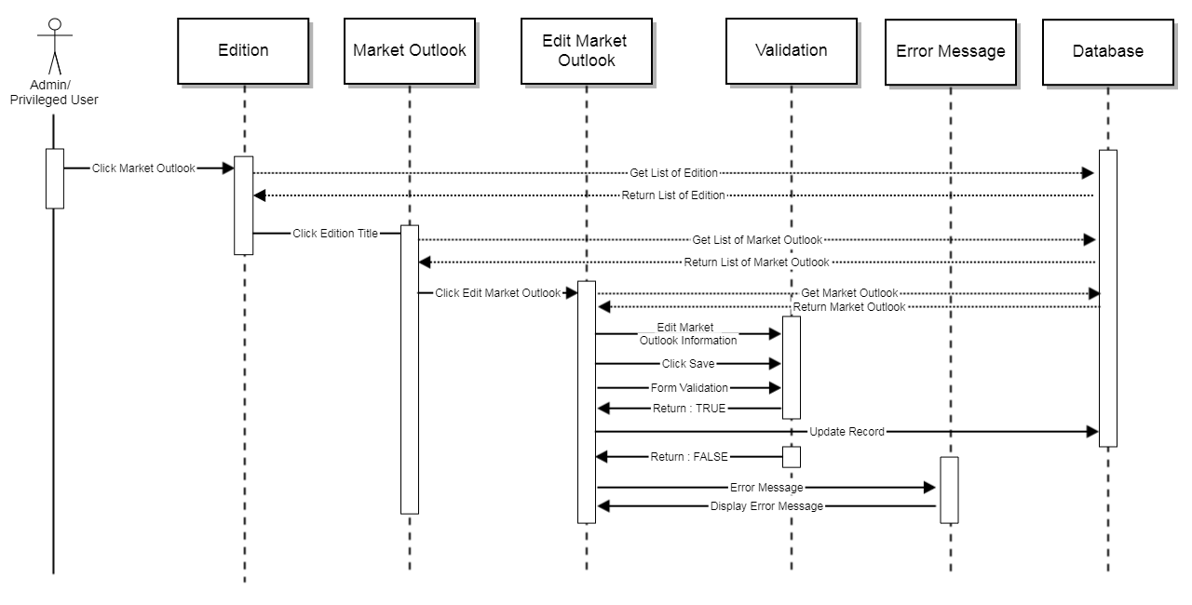
Sequence Diagram: Edit Market Outlook

Form Parameter
Request Parameter | Description | Type | Default | Required
Headline | Headline title | Text | Previously saved data | Yes
Description | Description | Text | Previously saved data | No
Category | Market Outlook category | Dropdown | Previously saved data | Yes
Date | Date created | Date | Previously saved data | No
Status | Status | Dropdown | Previously saved data | Yes
News content | Market Outlook content | Text | Previously saved data | Yes

Error Message
No | Message | Type | Description
1 | The title name field is required | Alert | Field cannot be null
2 | The title category description field is required | Alert | Field cannot be null
3 | The title status field is required | Alert | Field cannot be null
4 | The news content field is required | Alert | Field cannot be null

Screen Layout
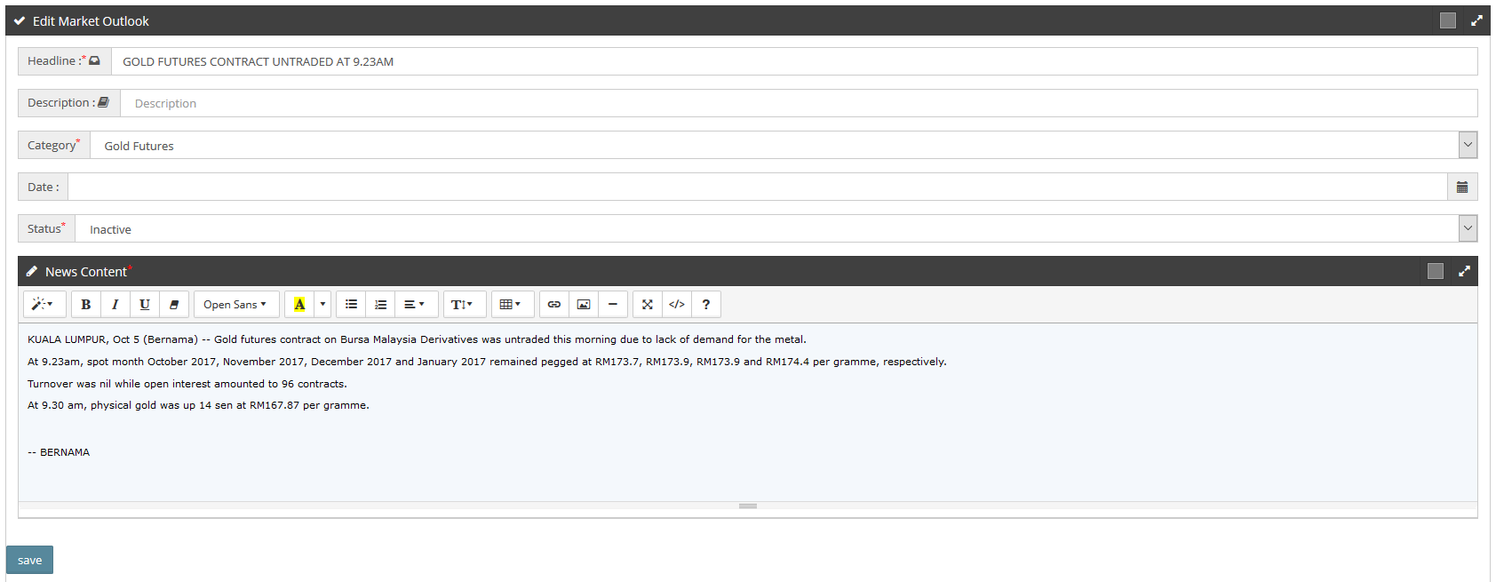
Screen Layout: Edit Market Outlook

Delete Market Outlook

Flowchart
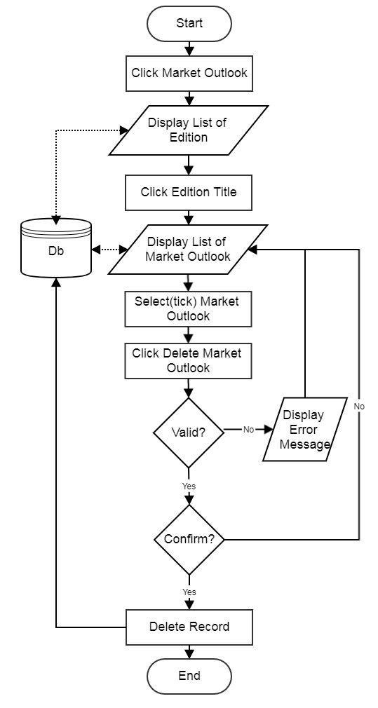
Flowchart: Delete Market

Sequence Diagram
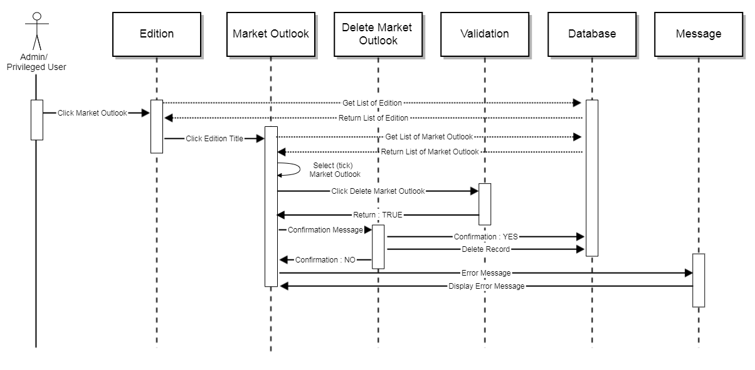
Sequence Diagram: Delete Market Outlook

Form Parameter
N/A

Error Message
No | Message | Type | Description
1 | Please Select at least one | Alert | Field cannot be null

Screen Layout
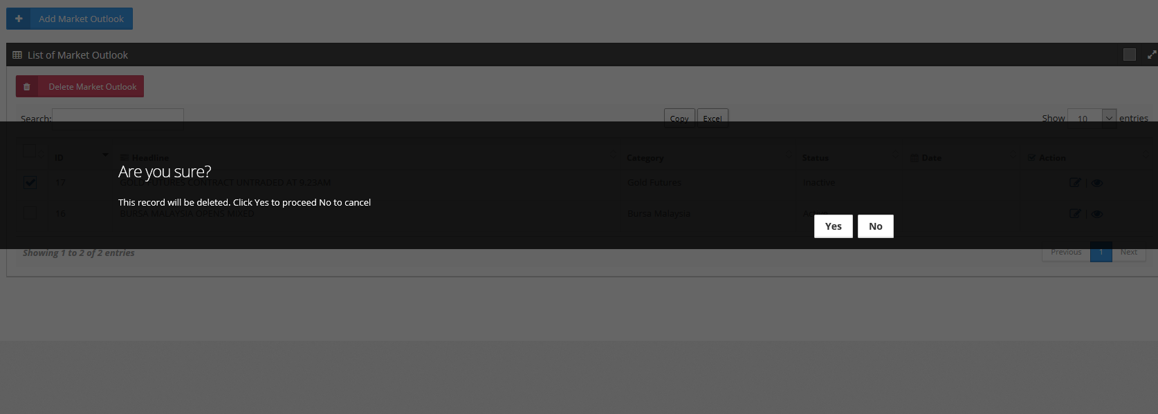
Screen Layout: Delete Market Outlook

Add Archive

Flowchart
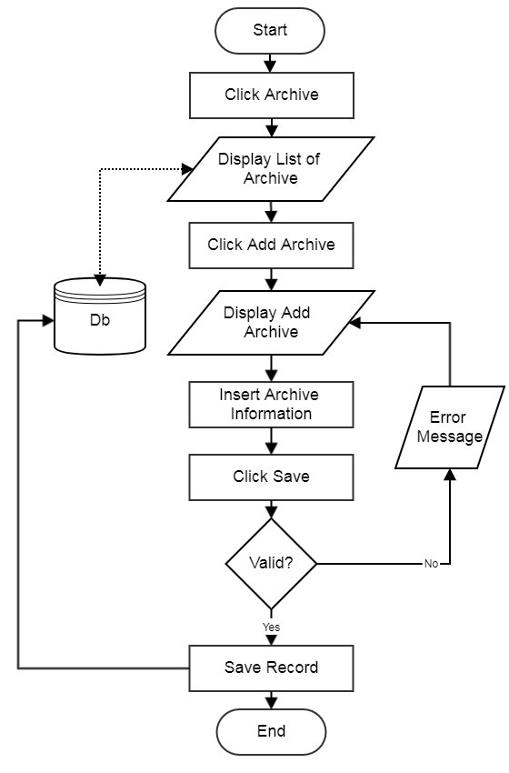
Flowchart: Add Archive

Sequence Diagram
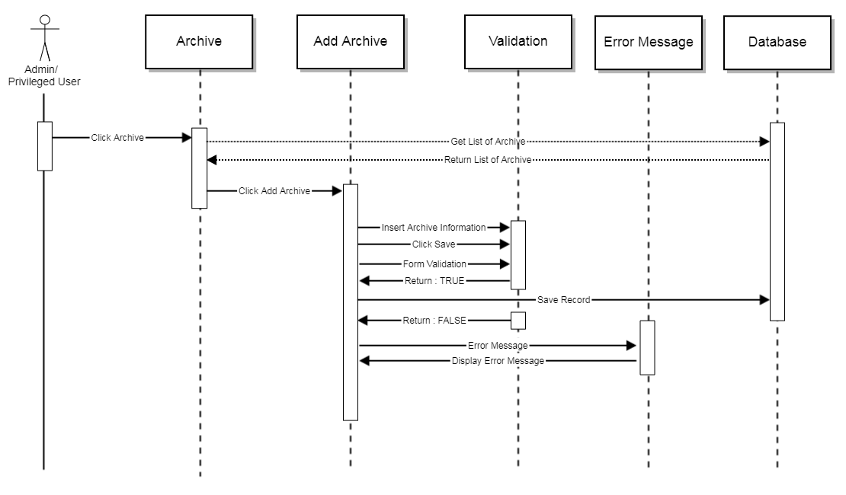
Sequence Diagram: Add Archive

Form Parameter
Request Parameter | Description | Type | Default | Required
Edition | Edition title | Text | N/A | Yes
Upload PDF | Upload file | File | N/A | Yes
Upload SWF | Upload file | File | N/A | No
Status | Status | Dropdown | N/A | Yes
Notes | Note | Text | N/A | No

Error Message
No | Message | Type | Description
1 | The title name field is required | Alert | Field cannot be null
2 | The pdf field is required | Alert | Field cannot be null
3 | The title status field is required | Alert | Field cannot be null

Screen Layout
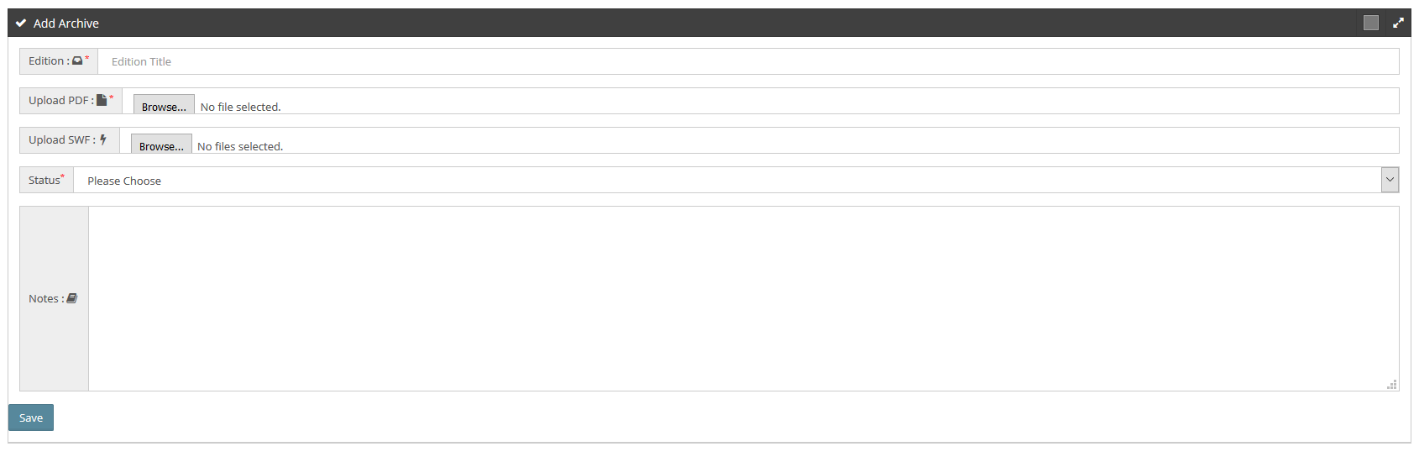
Screen Layout: Add Archive

View Archive

Flowchart
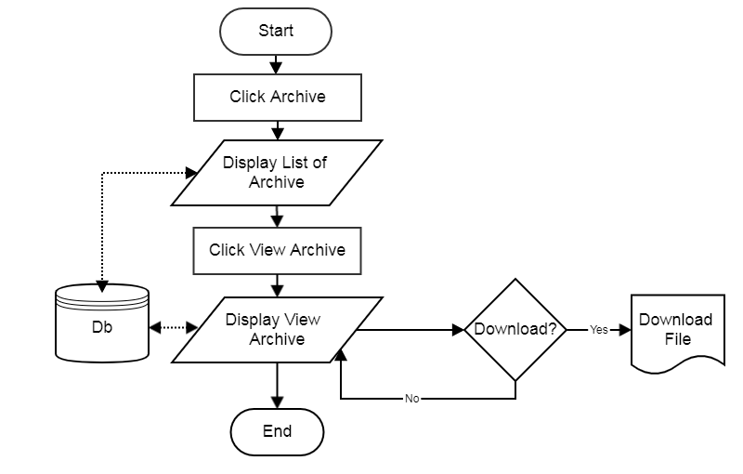
Flowchart: View Archive

Sequence Diagram
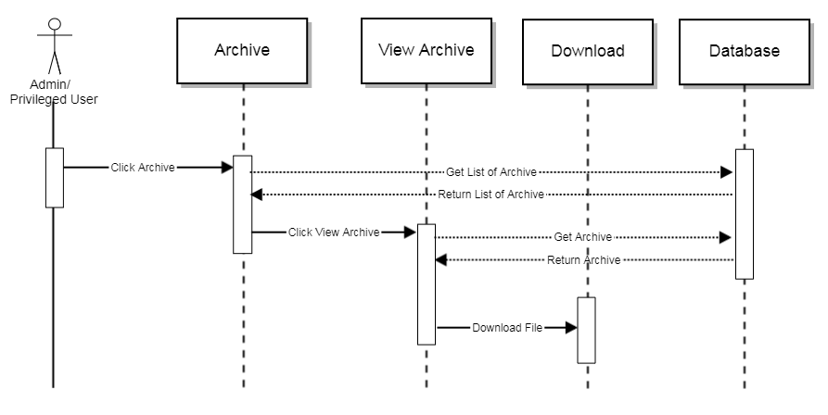
Sequence Diagram: View Archive

Form Parameter
N/A

Error Message
N/A

Screen Layout
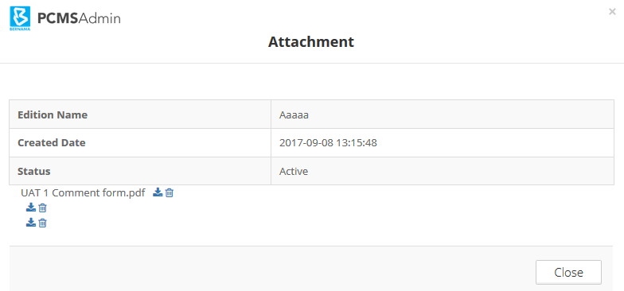
Screen Layout: View Archive

Edit Archive

Flowchart
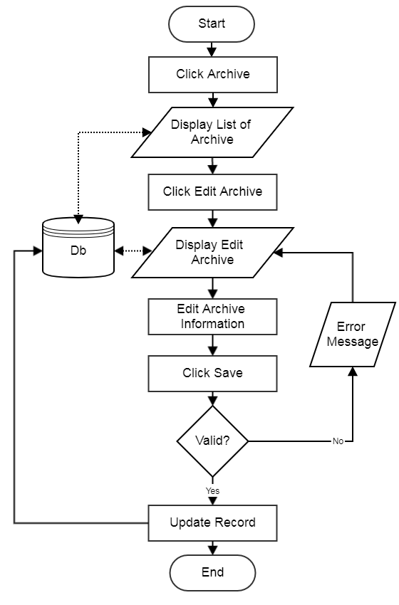
Flowchart: Edit Archive

Sequence Diagram
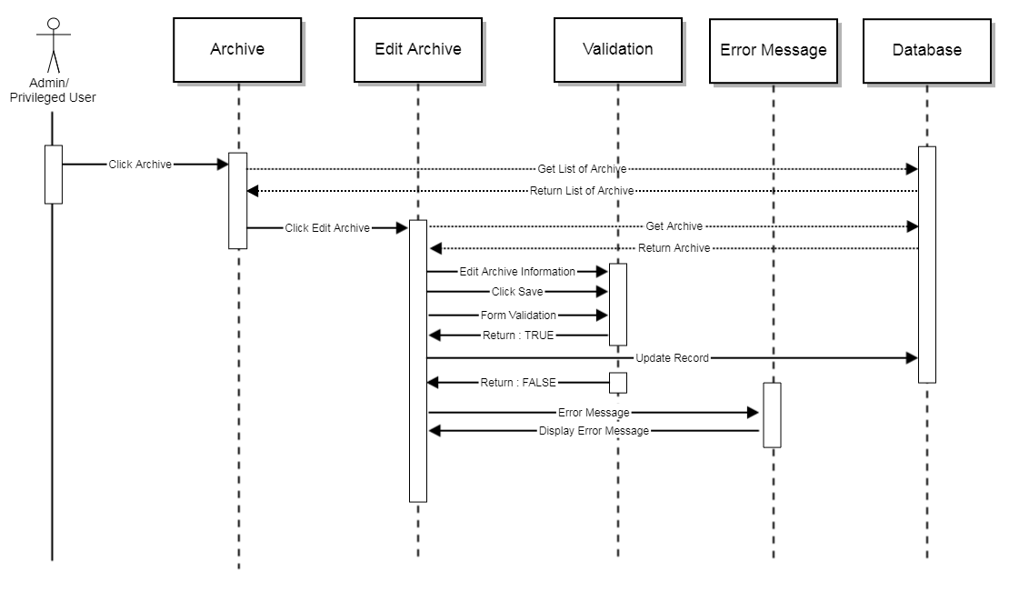
Sequence Diagram: Edit Archive

Form Parameter
Request Parameter | Description | Type | Default | Required
Edition | Edition title | Text | Previously saved data | Yes
Upload PDF | Upload file | File | Previously saved data | Yes
Upload SWF | Upload file | File | Previously saved data | No
Status | Status | Dropdown | Previously saved data | Yes
Notes | Note | Text | Previously saved data | No

Error Message
No | Message | Type | Description
1 | The title name field is required | Alert | Field cannot be null
2 | The pdf field is required | Alert | Field cannot be null
3 | The title status field is required | Alert | Field cannot be null

Screen Layout
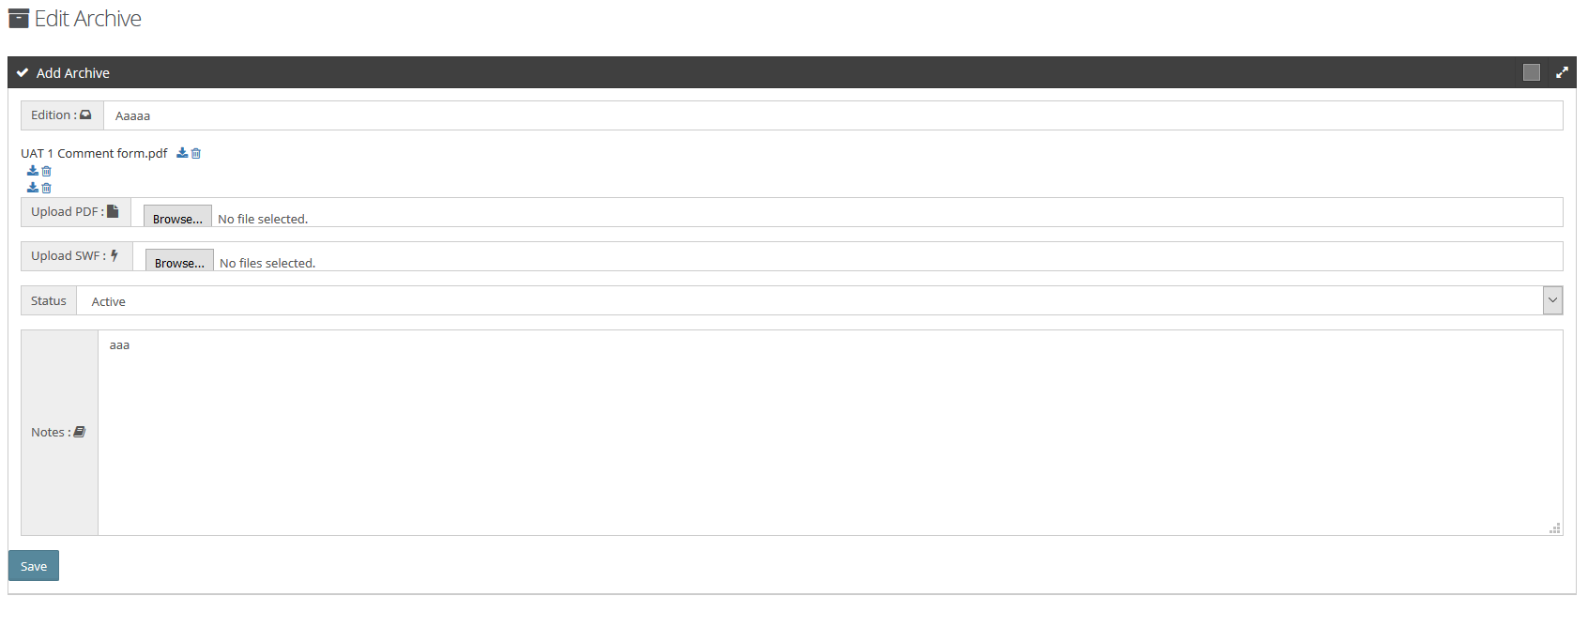
Screen Layout: Edit Archive

Delete Archive

Flowchart
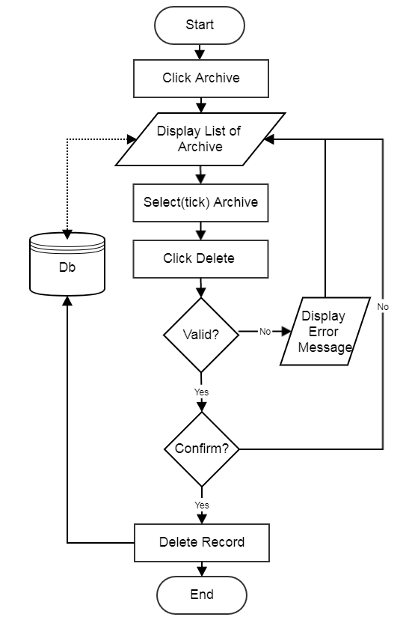
Flowchart: Delete Archive

Sequence Diagram
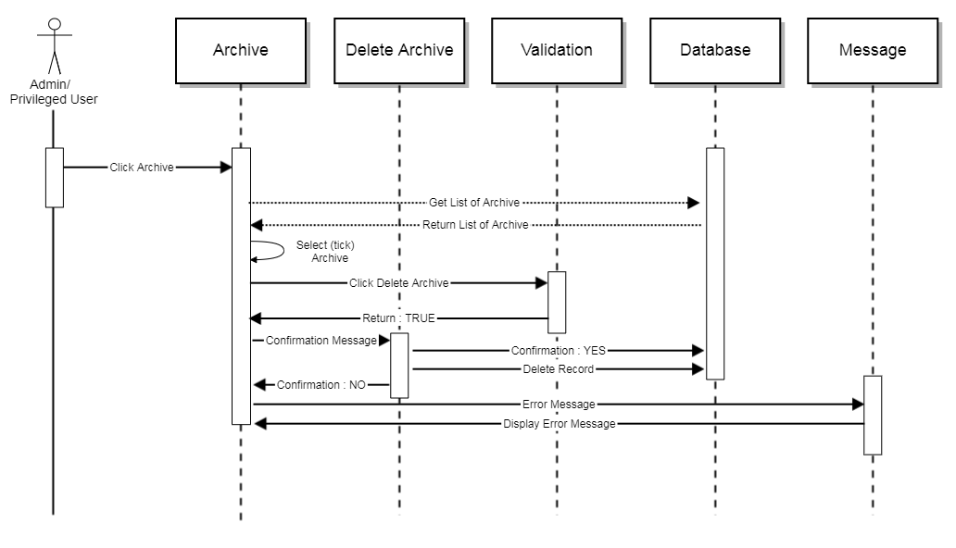
Sequence Diagram: Delete Archive

Form Parameter
N/A

Error Message
No | Message | Type | Description
1 | Please Select at least one | Alert | Field cannot be null

Screen Layout
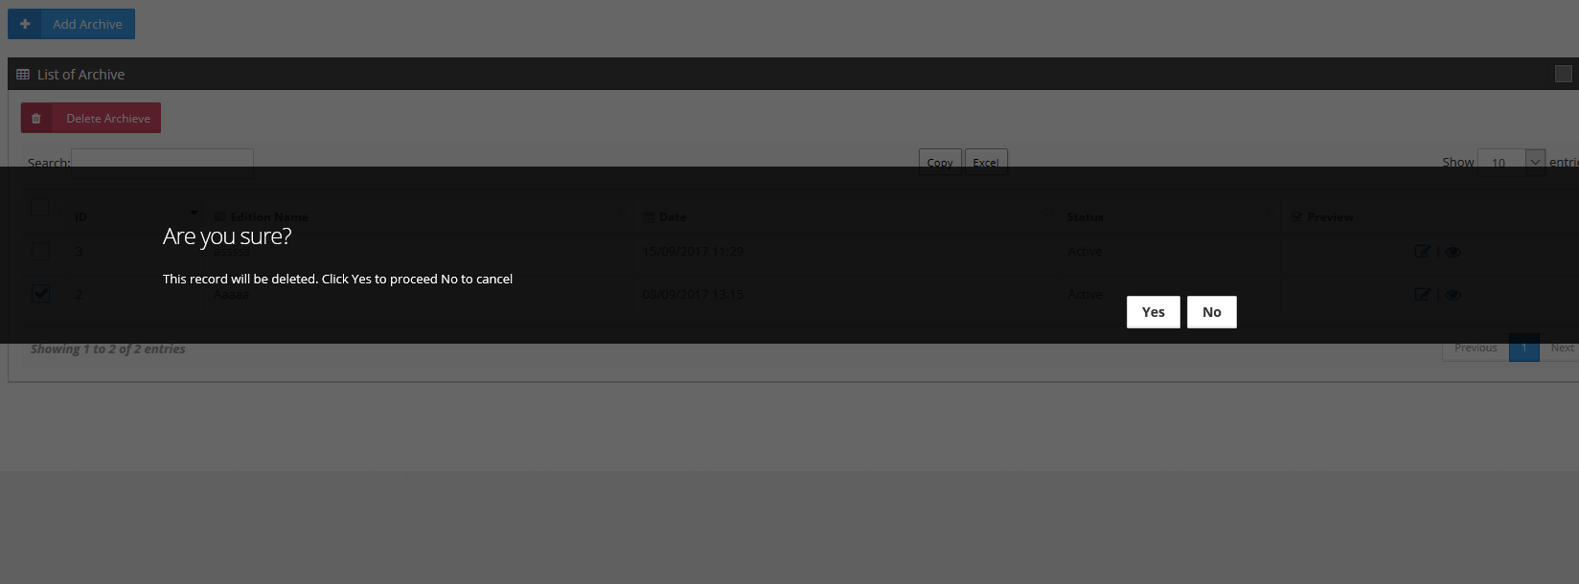
Screen Layout: Delete Archive

Module: Document Management

Use Case
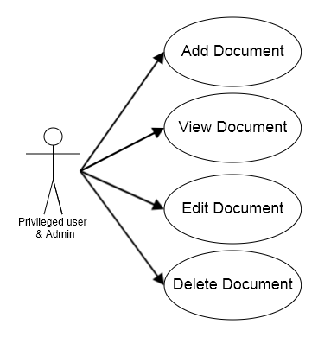
Use Case: Document Management

Use Case Description
Document Management Module provides a platform for various type of contents in different file format (all formats) to be uploaded into the system. It provides options to users whether to create the content directly using the text editor or upload the content file. There are six (6) document category can be choose:
- eNewsletter
- Tender
- Job Vacancy
- Speech
- Announcement
- Event

Text editor included in this module support the What You See Is What You Get (WYSIWYG) feature and have similar functions as the Microsoft Word. The news editor also designed to provision multiple languages and special characters. Multiple selection for delete function will be included as well as filter and sort functions within the system’s search feature. Other than that, this module is able to:
• Create, read, update and delete Document

Under module Document Management, privileged user should be able to access the following sub module:

- Add Document
Privileged user and admin shall add new document in this sub module by entering document’s information and uploading files or create the content in text editor.

- Manage Document
In this sub module, privilege user and admin have access to edit, view and delete the document.

Add Document

Flowchart
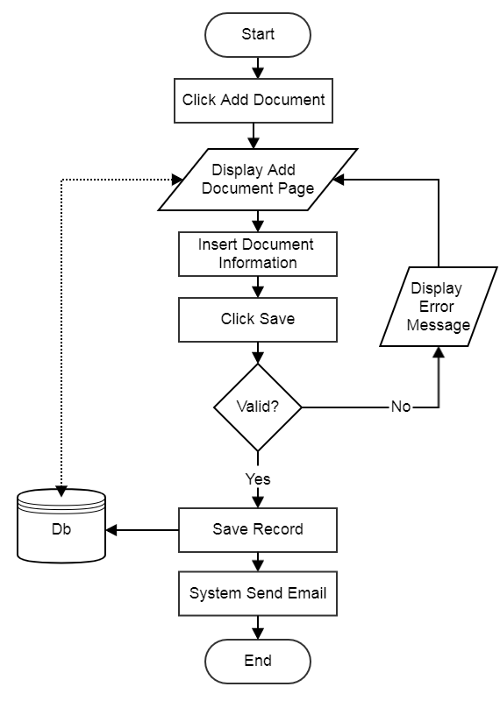
Flowchart: Add Document

Sequence Diagram
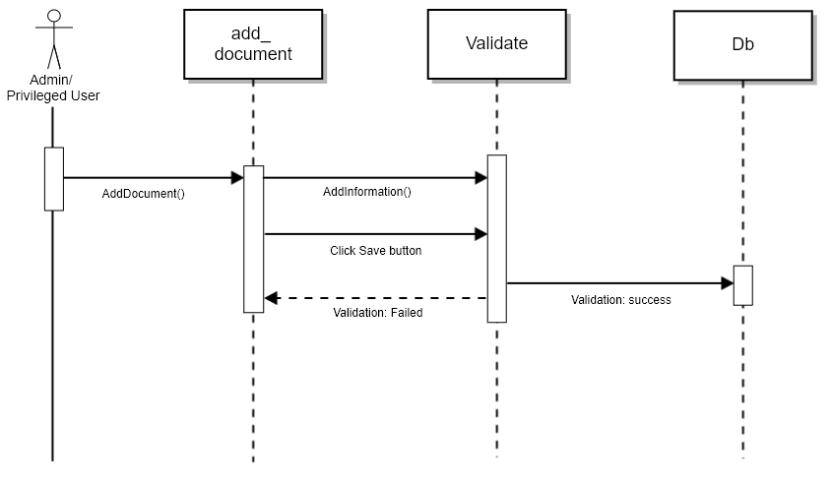
Sequence Diagram: Add Document

Form Parameter
Request Parameter | Description | Type | Default | Required
Document title | Document title | Text | N/A | Yes
Upload file | Upload file | File | N/A | No
Document Description | Document description | Text | N/A | No
Document category | Sub-Category | Dropdown | N/A | No
Document sub-category | Category | Dropdown | N/A | Yes
Language | Language | Dropdown | N/A | No
Status | Status | Dropdown | N/A | Yes
Start date | Start date | Date | N/A | No
End date | End date | Date | N/A | No
Notes | Notes | Text | N/A | No
Site Category | Site category | Dropdown | N/A | No
List of Site Category | List of site category | Dropdown | N/A | No

Error Message
No | Message | Type | Description
1 | The document title field is required. | Alert | Field cannot be null
2 | The document category field is required. | Alert | Field cannot be null
3 | The title status field is required | Alert | Field cannot be null

Screen Layout
Screen Layout: Add Document

View Document

Flowchart
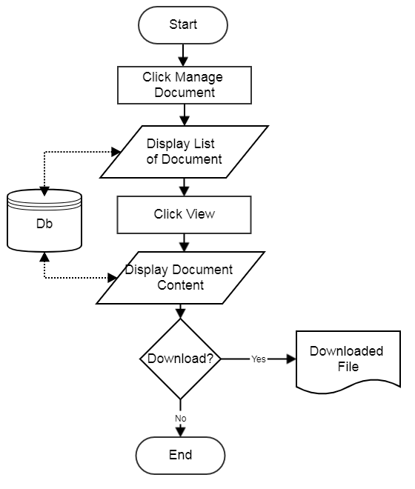
Flowchart: View Document

Sequence Diagram
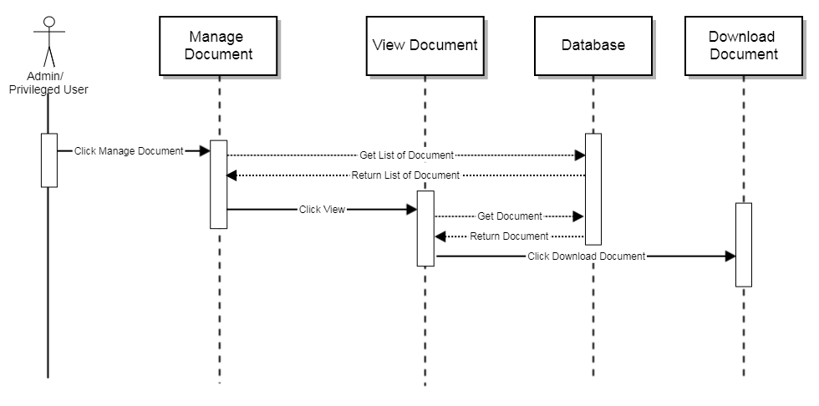
Sequence Diagram: View Document

Form Parameter
N/A

Error Message
N/A

Screen Layout
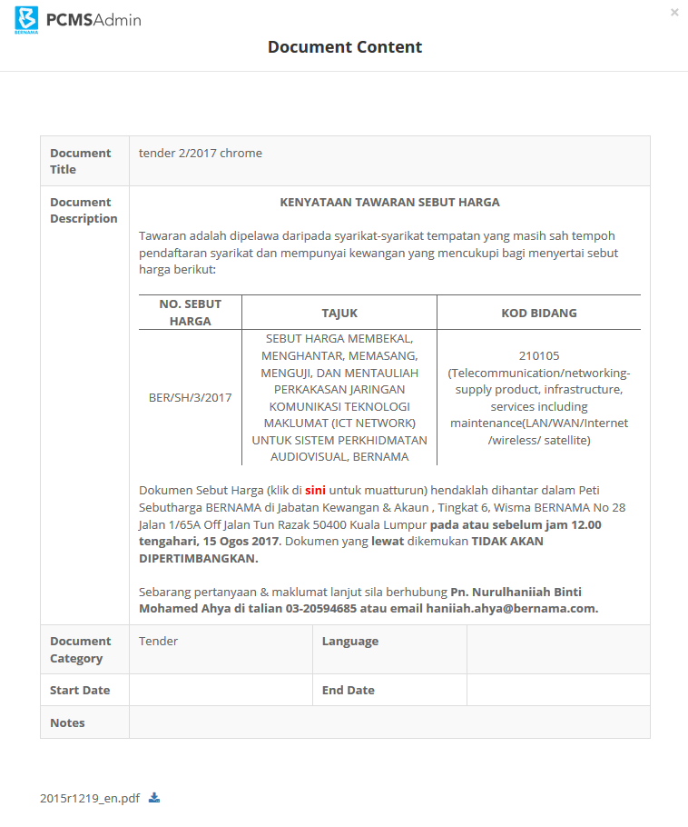
Screen Layout: View Document

Edit Document

Flowchart
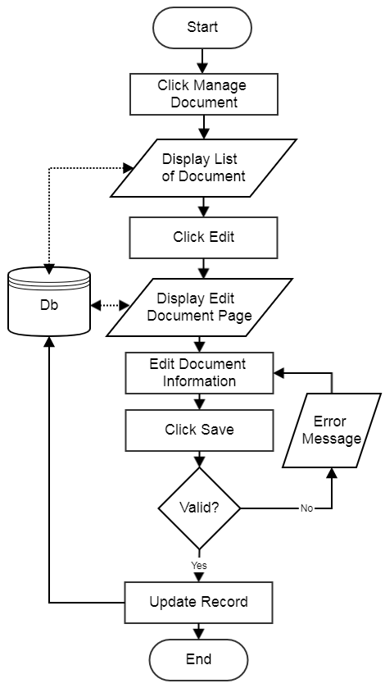
Flowchart: Edit Document

Sequence Diagram
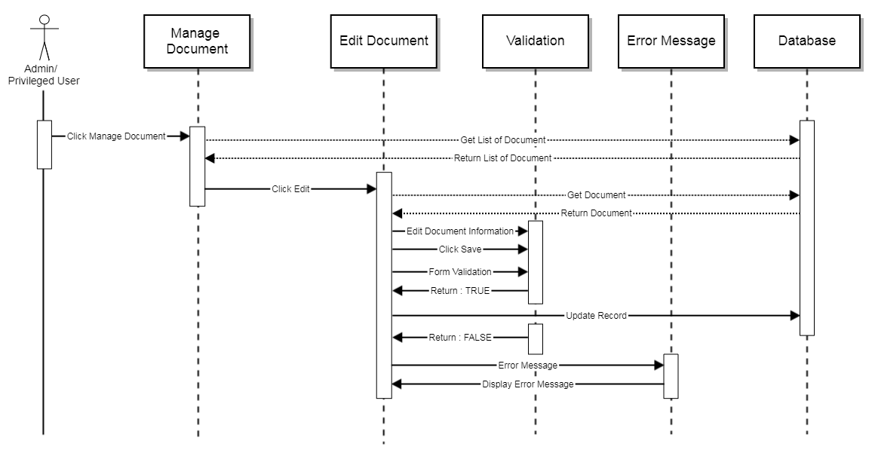
Sequence Diagram: Edit Document

Form Parameter
Request Parameter | Description | Type | Default | Required
Document title | Document title | Text | Previously saved date | Yes
Upload file | Upload file | File | Previously saved date | No
Document Description | Document description | File | Previously saved date | No
Document category | Category | Dropdown | Previously saved date | Yes
Document Sub-category | Sub-Category | Dropdown | Previously saved date | No
Language | Language | Dropdown | Previously saved date | No
Status | Status | Dropdown | Previously saved date | Yes
Start date | Start date | Date | Previously saved date | No
End date | End date | Date | Previously saved date | No
Notes | Notes | Text | Previously saved date | No
Site Category | Site category | Dropdown | Previously saved date | No
List of Site Category | List of site category | Dropdown | Previously saved date | No

Error Message
No | Message | Type | Description
1 | The document title field is required. | Alert | Field cannot be null
2 | The document category field is required. | Alert | Field cannot be null
3 | The title status field is required | Alert | Field cannot be null

Screen Layout
Screen Layout: Edit Document

Delete Document

Flowchart
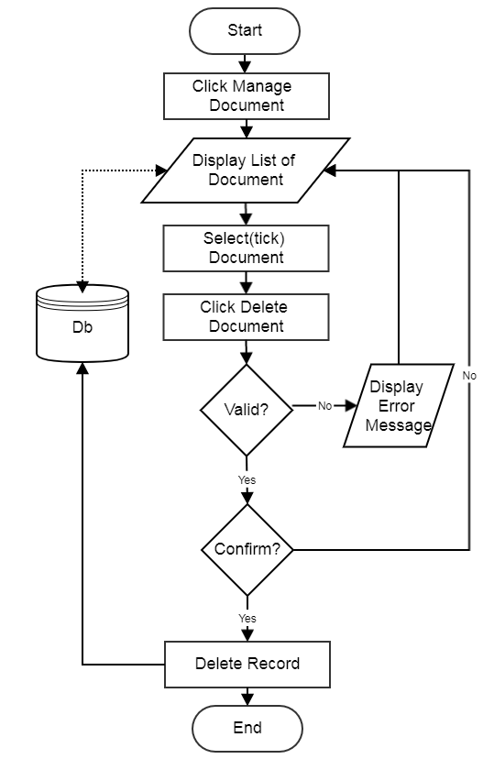
Flowchart: Delete Document

Sequence Diagram
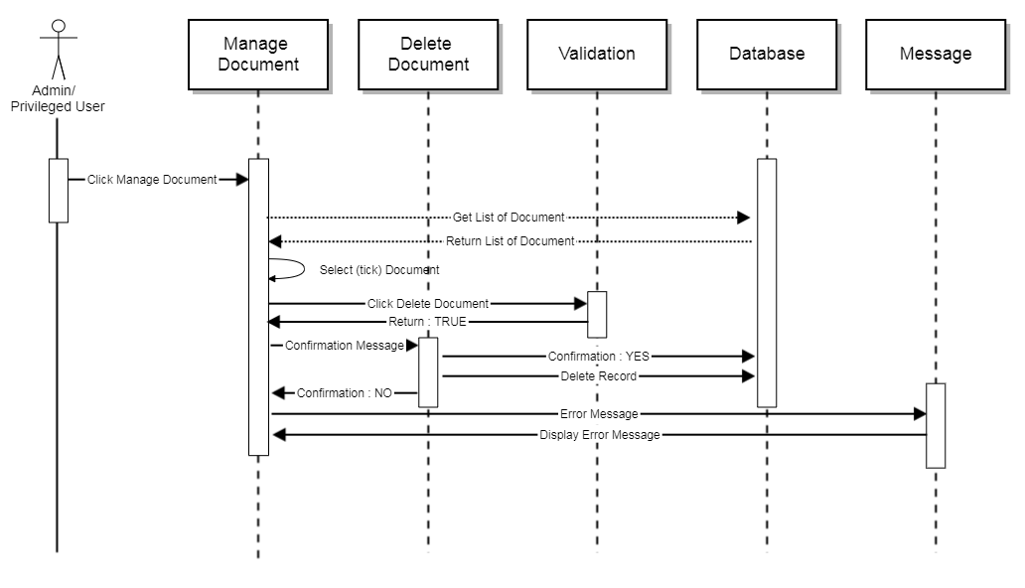
Sequence Diagram: Delete Document

Form Parameter
N/A

Error Message
No | Message | Type | Description
1 | Please Select at least one | Alert | Field cannot be null

Screen Layout
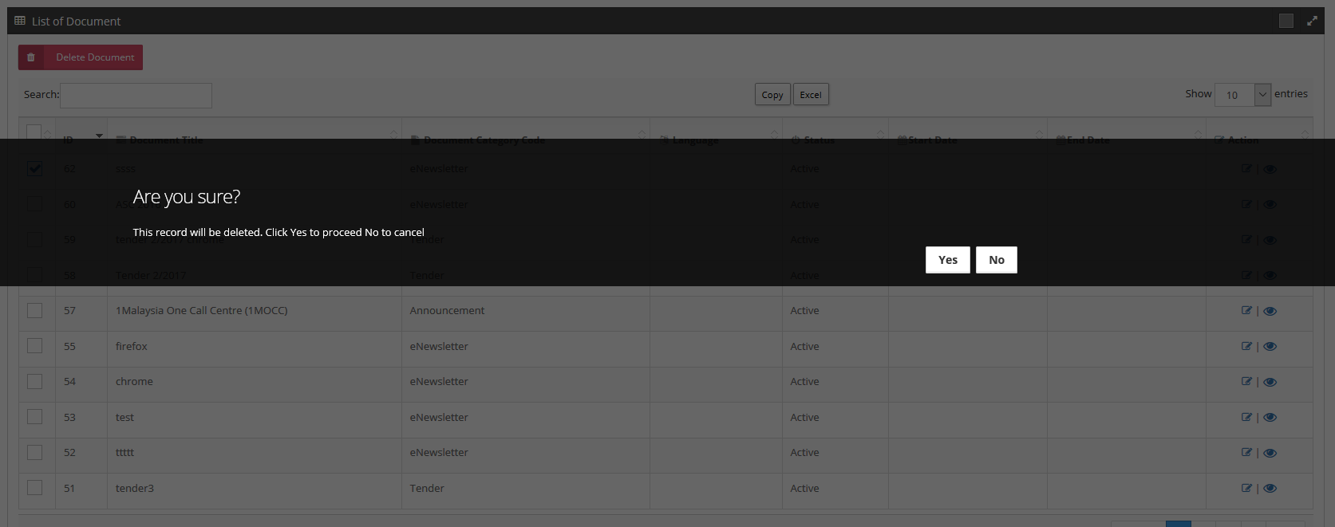
Screen Layout: Delete Document

